OCS SCRAPBOOK - DEC ’57 CLASS
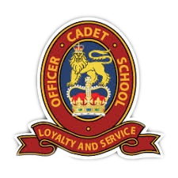
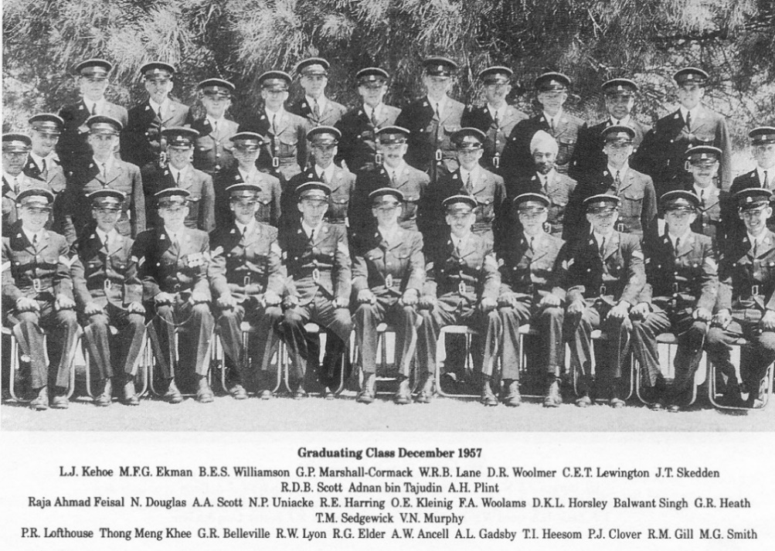
OCS TEAMS 1957
CRICKET 1ST TERM
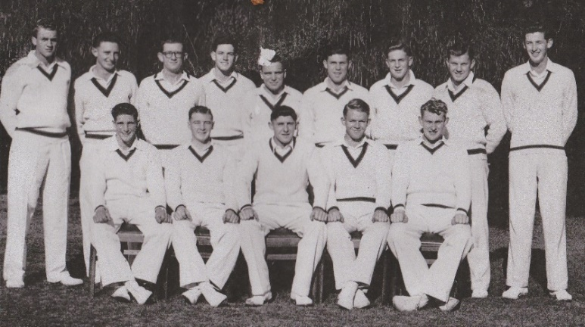
Rear L to R: Rob Lyon, Bob McGhie, Jim Skedden, Alan Plint, Peter Lofthouse, Brian Doyle, Tom Heesom, Michael Gill & Michael Smith.
Front L to R: Jack Campbell, Peter Belt, Don Woolmer, Peter Scott & Bob Halverson.

/OCS TEAMS 1957 CONT:
OCS RUGBY 1957
RUGBY XV 1ST TERM

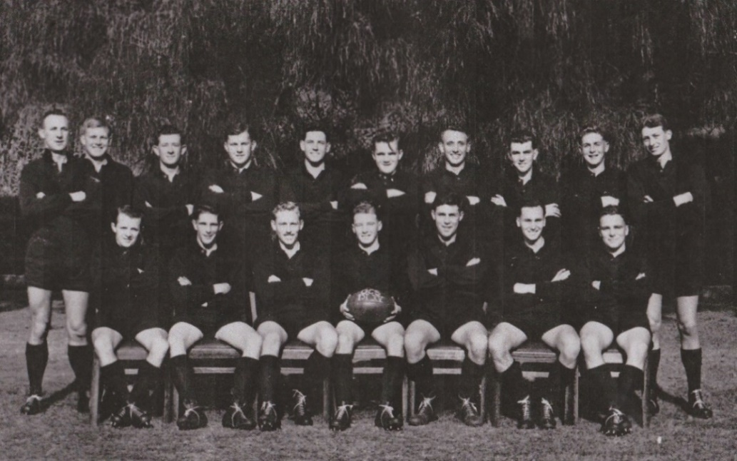

Rear L to R: Reg Elder, Grant Fielding, Jim Skedden, Michael Gill, Alan Plint, Don Randall, Arthur Gadsby,
Michael Ekman, Tom Heesom & Tony Ancell.
Front L to R: Barry Williamson, Jack Campbell, John Neenan, Peter Belt, Brian Doyle, Ossie Kleinig & Peter Lofthouse.

RUGBY XV 2ND TERM

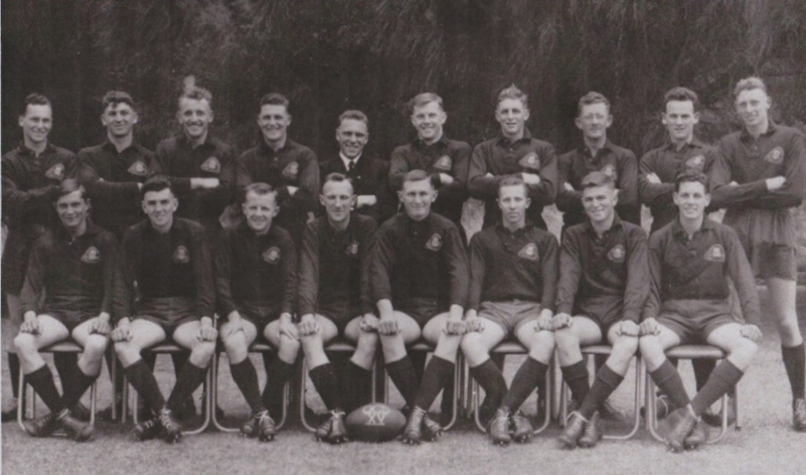

Rear L to R: Ossie Kleinig, Bill Lunney, Arthur Gadsby, Les Kehoe, Peter Lofthouse, Michael Gill, Tom Heesom,
Jim Skedden, Quin Rodda & Tony Ancell.
Front L to R: Dave Horsley, Michael Ekman, Barry Williamson, Reg Elder, Bob Bleakley, Barry Hawkins, Wally Lane & Alan Plint.
/OCS TEAMS CONT:

OCS REPRESENTATIVE RUGBY -1957 & 1966

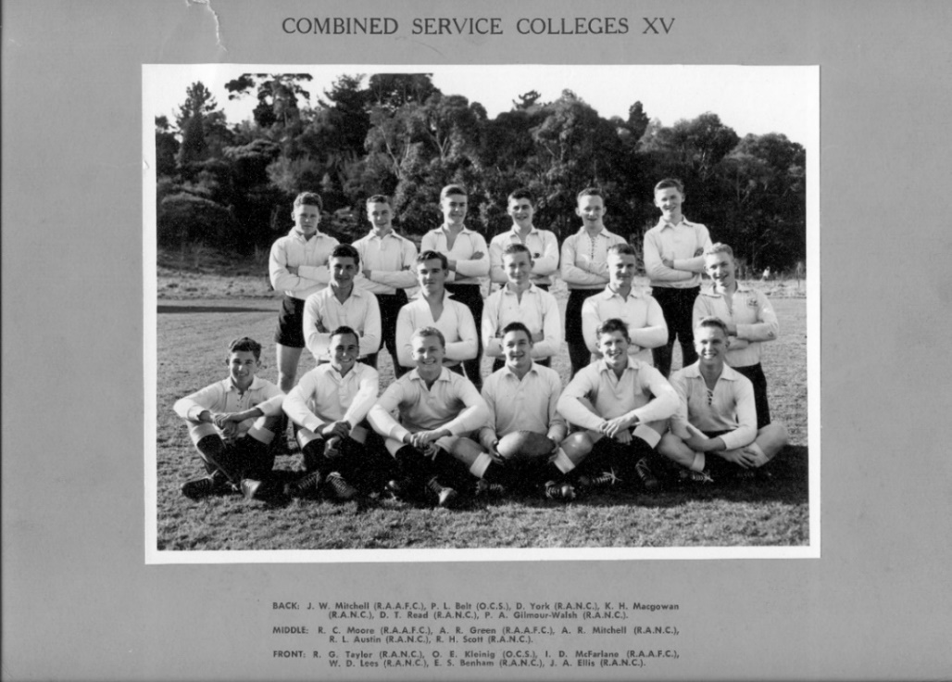

Rear Rank 2nd from L: Peter Belt. Front Rank 2nd from Left: Ossie Kleinig.

AND BACK ON STAFF JAN ’65 TO JUN ’67 – VRU PREMIERS 1966

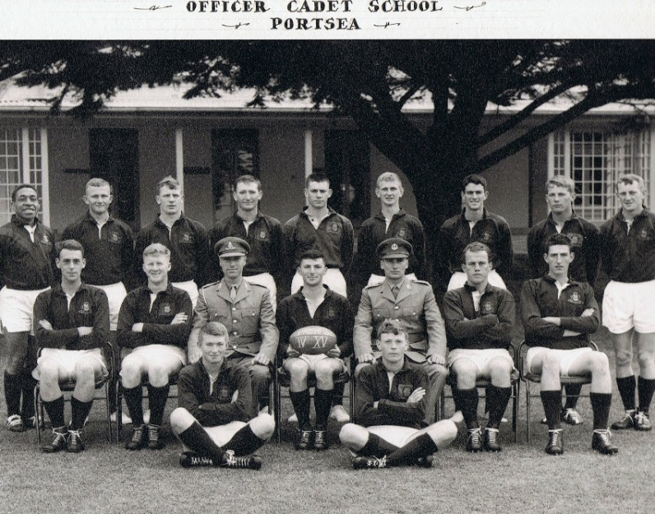

Rear L to R: J. Kupogut, M. Boyle, R. Bates, R. Dakers, G. Prendergast, J. Hyde, M. Hampton, B. Darr & G. Watson.
Centre Row L to R: J. Fisher, D.Duke, Capt David Solomons RAA, N. Howlett, Capt Ossie Kleinig RA Inf, D. Crooks & W. Menzies.
Front L to R: T. Daniel & M. Brown.
/OCS TEAMS CONT:
BOXING

OCS WEIGHT DIVISION CHAMPIONS 2ND TERM

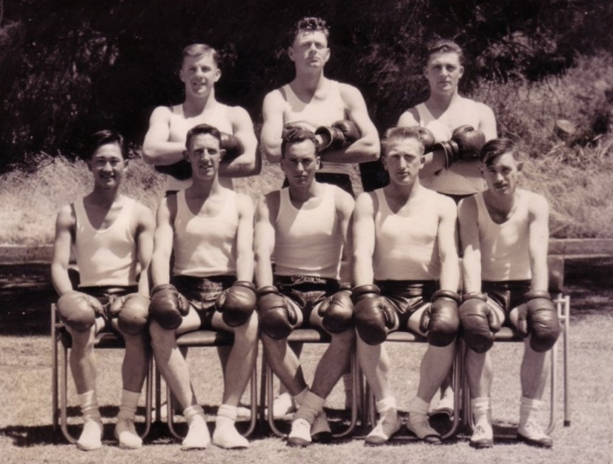

Rear L to R; Michael Gill, Peter Howarth & Les Kehoe.
Front L to R: Thong Meng Kee, John Clarke, Ossie Kleinig, Terry Holland & Terry Sedgwick.

MAJOR PETER COOK, RA INF, DELIVERS “THE LAST RITES”

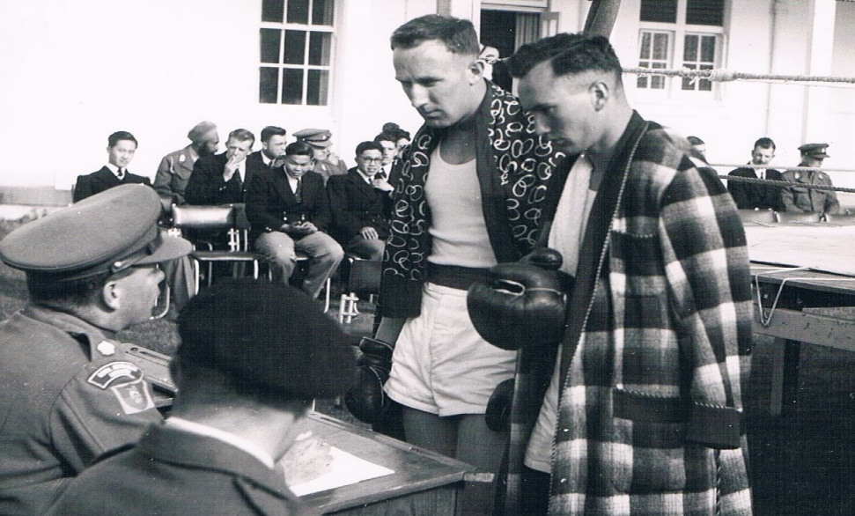

L to R: Combatants - Reg Elder & Ossie Kleinig share their forebodings. Spectator gallery shows absolutely no concern.
/OCS TEAMS CONT:
NOT SURE WHAT HAPPENS NEXT?

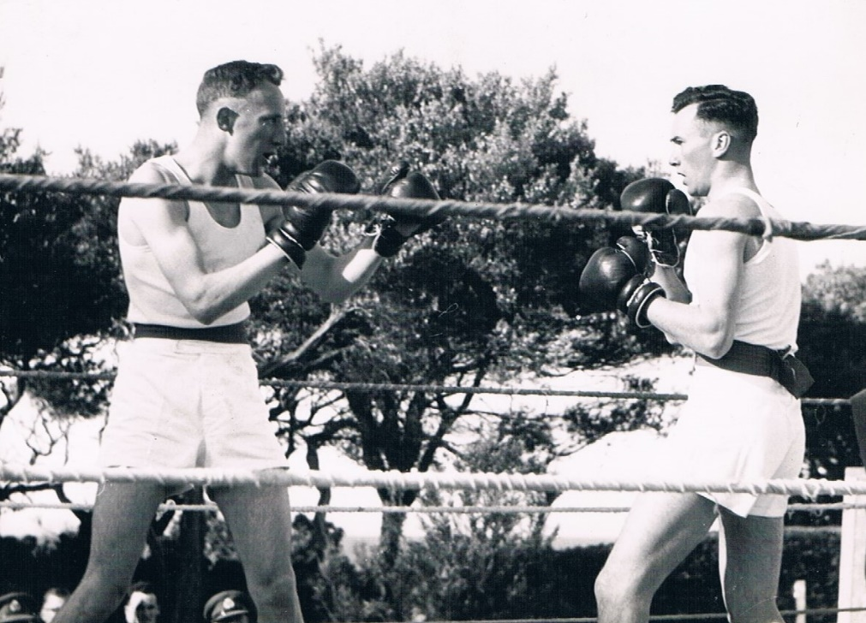

The BIG Question: Can we keep up this shadow-boxing for three rounds?

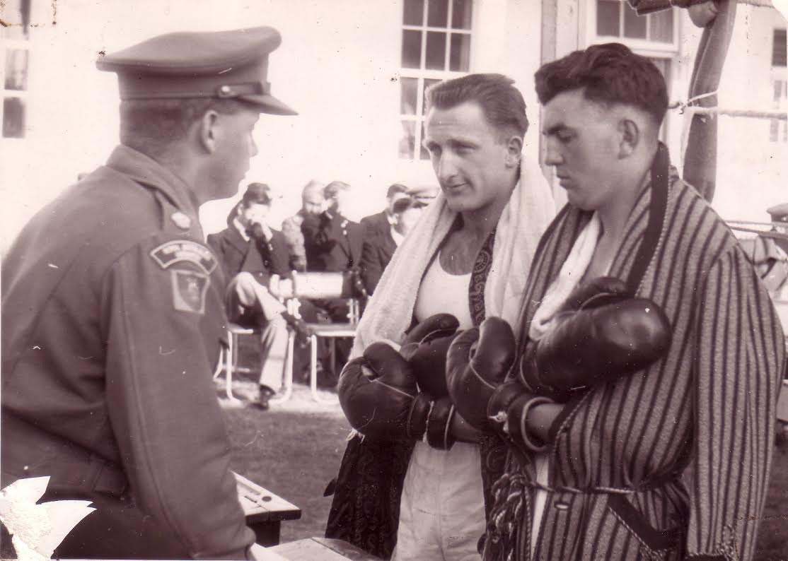

Terry Holland Vs Mick Ekman in pre-bout briefing. “No Bundaberg rules here Mr Holland!”
/OCS TEAMS CONT:
“COOKIE” GETS MORE ENTHUSIASTIC IN HIS PRE-BOUT BRIEFING

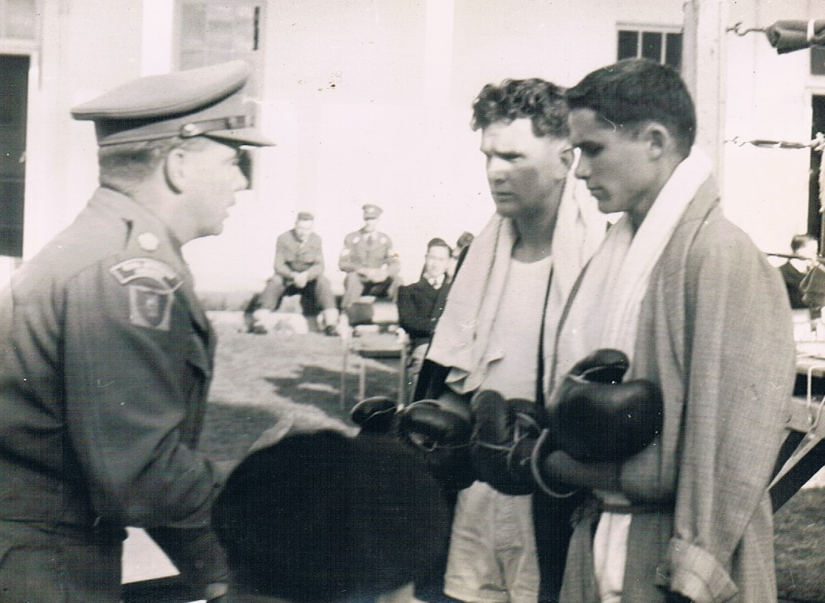
Norm Uniacke in a serious mood & Tony Scott is just downcast.

ATHLETICS
INTER COLLEGE ATHLETICS’ MEETING 1957 – THE TEAM

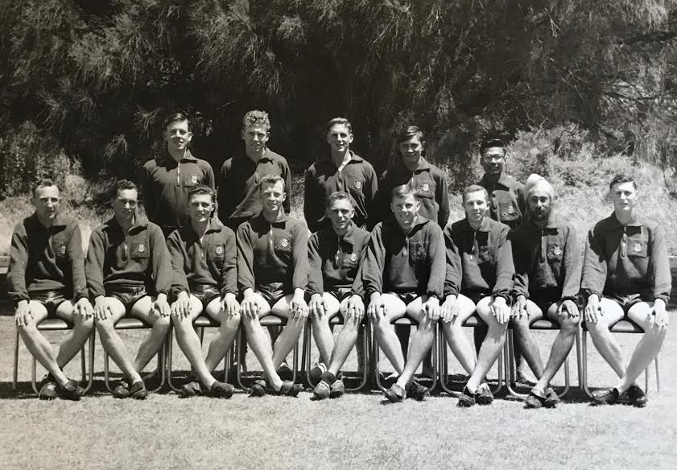

Rear L to R: Max Ball, Carl Lewington, Tom Heesom, Dave Horsley & Raja Ahmad Feisal.
Front L to R: Reg Elder, Ossie Kleinig, Les Kehoe, Bob Tanner, Peter Lofthouse, Michael Gill, Barry Hawkins, Balwant Singh & Geoff Chipman.

/OCS TEAMS CONT:

INTER SERVICE COLLEGE ATHLETICS’ MEET [ISCAM] 1957
RAN NAVAL COLLEGE FLINDERS, OCS PORTSEA & RAAF COLLEGE POINT COOK

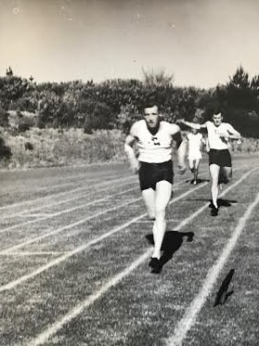

Michael Gill hands over baton to Bob Tanner in final 440 yards relay leg.
Meet won by RNC with OCS Runner Up. OCS Champion Athlete 1957: Bob Tanner.

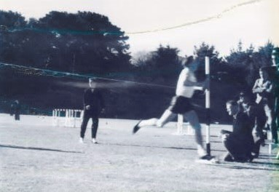

Michael Gill winning the Individual 440 yards ISCAM Championship.
/OCS TEAMS CONT:
ATHLETICS MEET CONTINUED

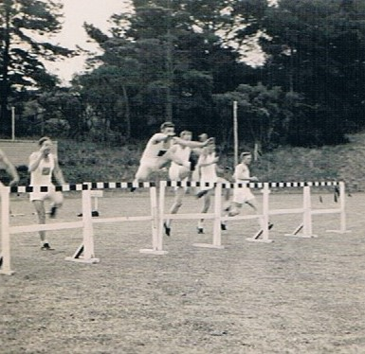

100 yards Hurdles. Tom Heesom’s Event.

BROAD JUMP

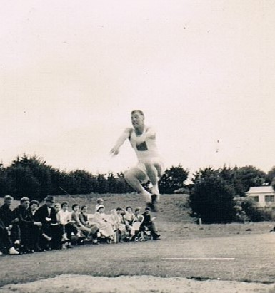
Michael Gill flies for OCS.

/OCS TEAMS CONT:
HOP, STEP & JUMP

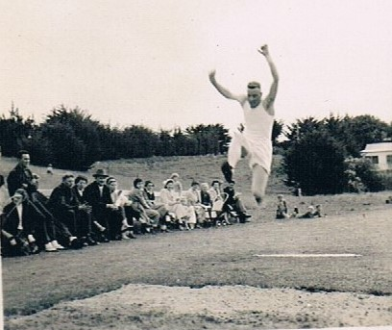

Bob Tanner does it for OCS.

AND THE FINAL EVENT

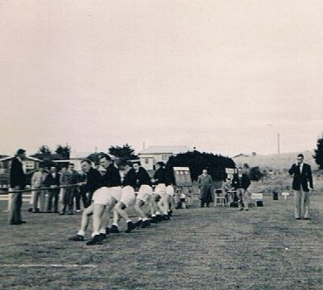
OCS Tug-of-War-Team.
/OCS TEAMS CONT:
OCS PARTICIPANTS/SPECTATORS AT INTER SERVICE COLLEGE ATHLETICS’ MEET

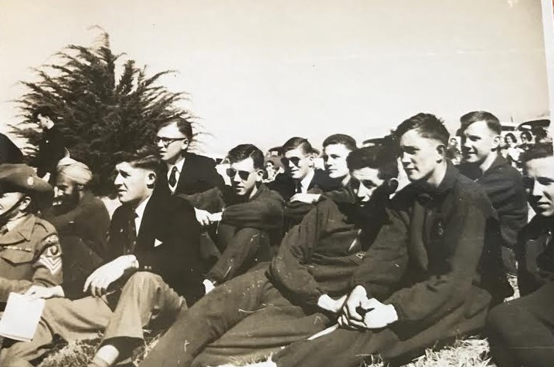

Fm L to R: RAP Sgt “Doc” Savige in uniform, Balwant [in turban], Don Woolmer, Jim Skedden [rear],
Max Ball, Wally Lane & Les Kehoe [rear], Mike Smith, Dave Horsley, Michael Gill [rear] & Barry Hawkins.

MEET RESULTS WERE LOOKING GOOD FOR OCS

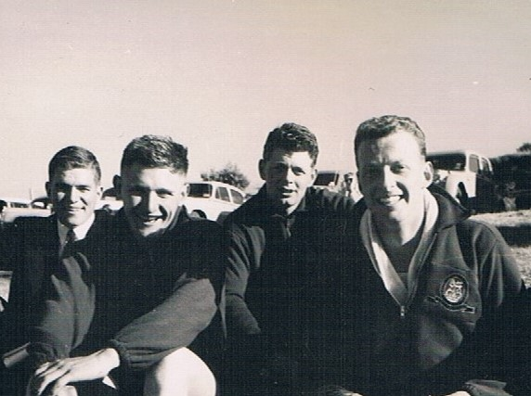

L to R: Wally Lane, Phil Clover, Peter Howarth & Bob Tanner.
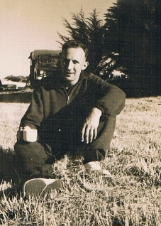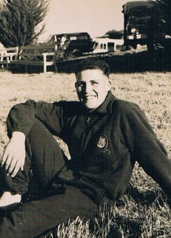
L to R: Reg Elder & Les Kehoe mentally preparing for next event.
/OCS TEAMS CONT:
THE PRESENTATION

FINAL SCOREBOARD

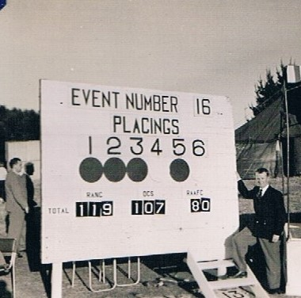

“C’mon Barry – 13 Points needed?”
[Scoreboard Attendant: Barry Williamson]

AND THE WINNING COLLEGE – OCS BEATEN BY A WHISKER!

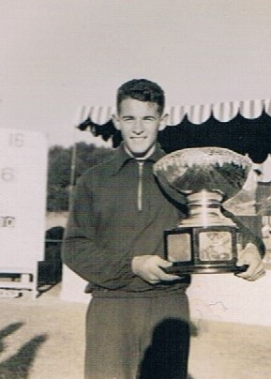
Flinders Naval College [RANC] Team Captain accepts Meet Trophy.

1957 CONCERT
THE KIWI INVASION HAKA
[The first two Kiwi Intakes at OCS]

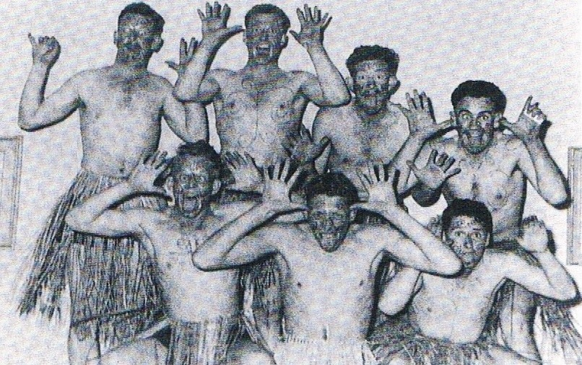

THE ORIGINALS MINUS ARTHUR GADSBY
Rear L to R: Ben Woolams, Bob Tanner, Jim Skedden & Quin Rodda.
Front L to R: Peter Scott, Tony Ancell & Brian Cudby. Absent: Arthur Gadsby [in hospital].

A TAKE ON OUR ARMOURED CORPS INSTRUCTOR
[Captain Don R Chapell, RAAC].

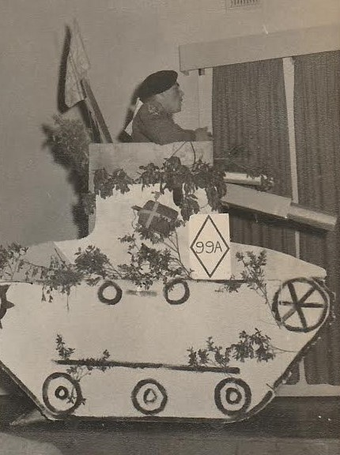

Peter Lofthouse "hams" it up for the assembled multitude in a Mark 10 “something”.
IN MEMORIAM – CAPTAIN GRAEME BELLEVILLE, RA INF

Age shall not weary nor the years condemn!

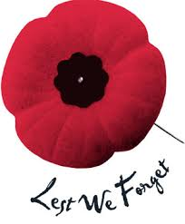

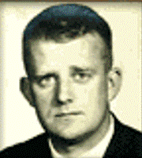
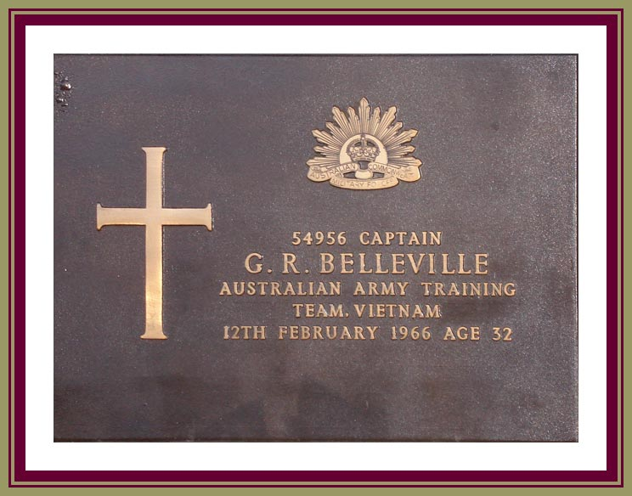

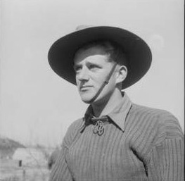

Graeme served with 2 RAR in Korea. He also served in Malaya still with 2 RAR in 1955 & ‘56
before entering OCS in the Jan ‘57 Intake. Graduated as a member of the OCS Dec ’57 Class to Infantry. Our only classmate to be Killed-in-Action. RIP Graeme!

VALE – OCS CLASS OF DEC 1957
AUSTRALIAN ARMY
[As at 10 Feb 2022].

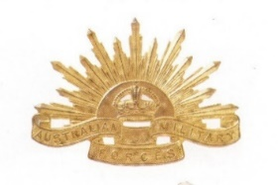

RAAC RAE
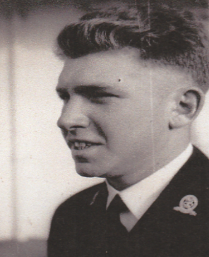
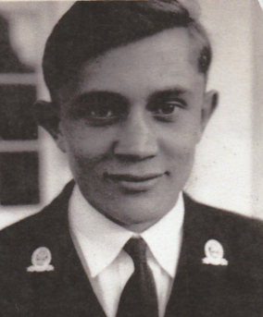
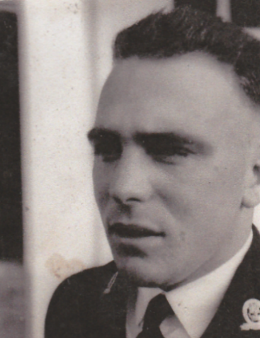
Carl Lewington. David Horsley. Peter Lofthouse.
RAA

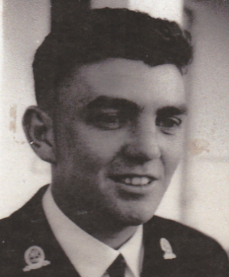
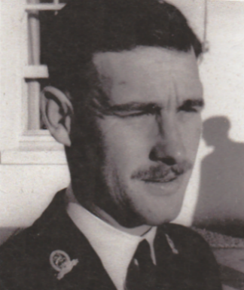

Terry Sedgwick. Michael Ekman.

VALE CONT:
RA INF

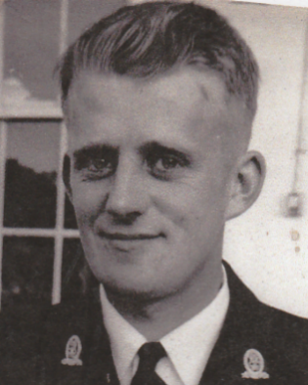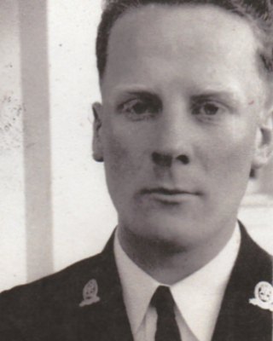

Graeme Belleville, KIA Vietnam. Vin Murphy.
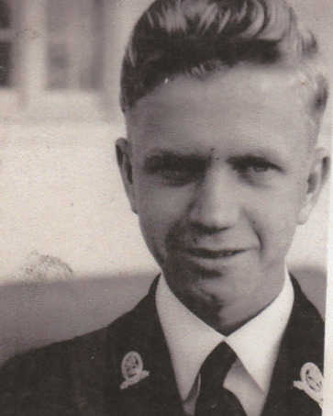
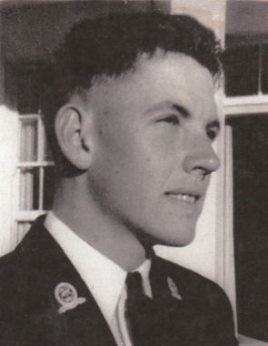
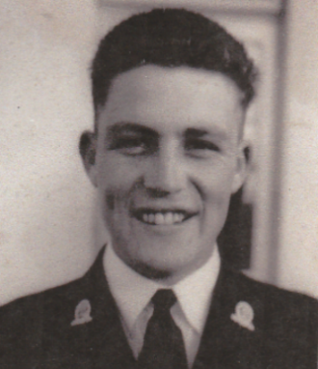
Ray Harring. Les Kehoe. Alan Plint.
RAASC RAAOC RAEME
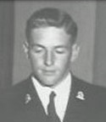
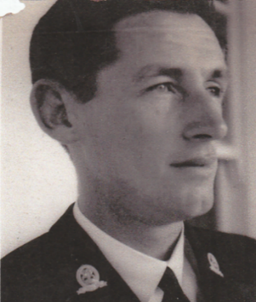
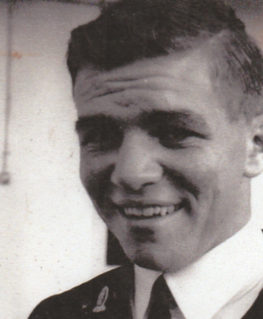

Tom Heesom.
Wally Lane. Michael Smith.
VALE – OCS CLASS OF DEC 1957
NEW ZEALAND ARMY

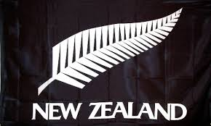

NZ INF REGT

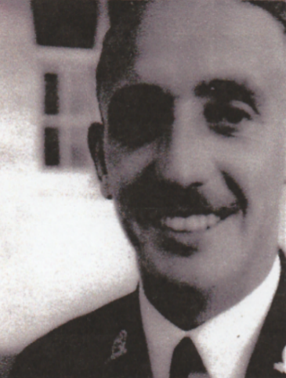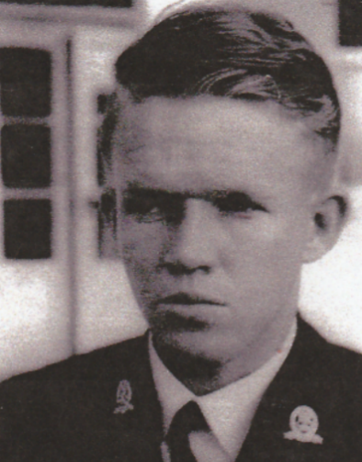

Arthur Gadsby. Peter Scott.

RNZAOC RNZEME

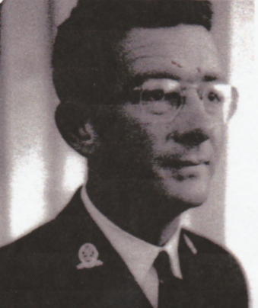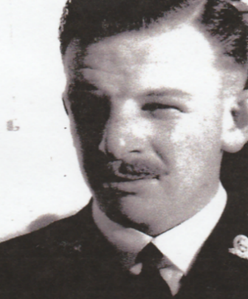

Jim Skedden. Ben Woolams.

VALE OCS CLASS OF DEC 1957
MALAYAN [NOW MALAYSIAN] ARMY

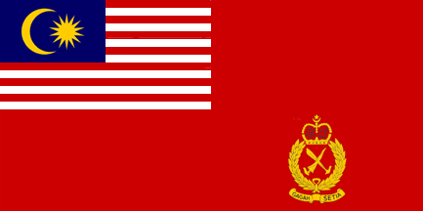
MGSC

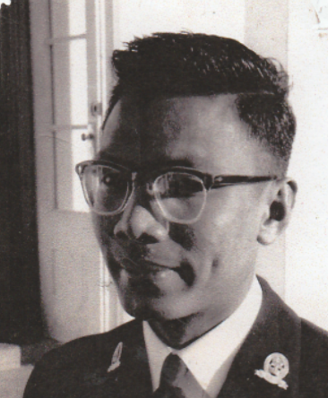

Raja Ahmad Feisal.

FLAME OF REMEMBRANCE – ANZAC SQUARE – BRISBANE
NOVEMBER 2008

“WE WILL REMEMBER THEM”

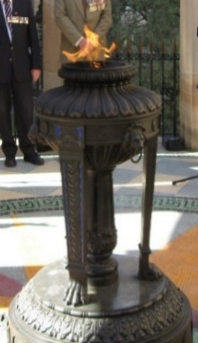
“Lest We Forget”.
RAASC MILITARY DRIVING COURSE

WHO’s RESPONSIBLE??

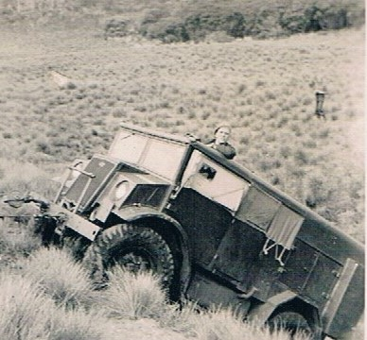

It was just a small hole really!!!
NEARLY OUT!

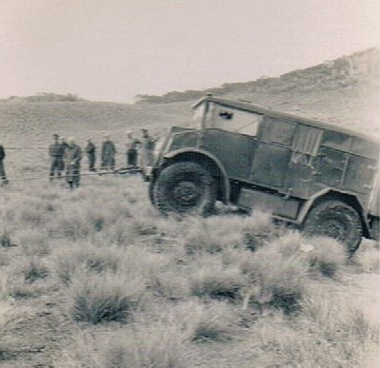

We could do without the spectators!

MILITARY DRIVING COURSE CONT:
ON THE ROAD AGAIN!

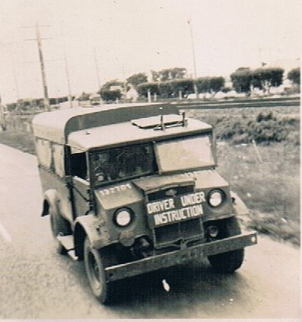

Easy!

THE DEBRIEF

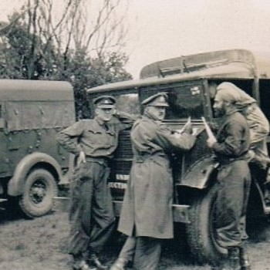

Reg Elder, WO 2 Colin Lander & Balwant Singh.
“Yes Balwant, apart from running six red lights!!!”
A VISIT TO HMAS SYDNEY – MAY ‘57

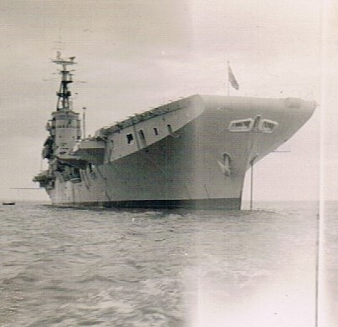

For some this was not the last introduction to HMAS Sydney.
“The Vung Tau Ferry” in later years.

WHAT! UP THERE??

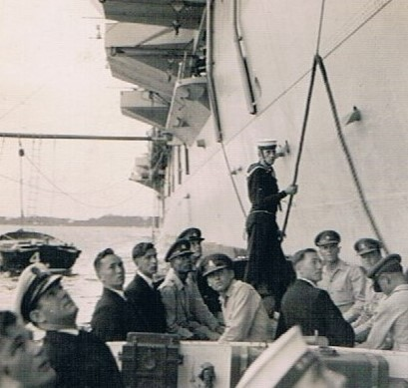

You’ve got to be joking!
OCS DEC ’57 CLASS - GRADUATION PHOTOS

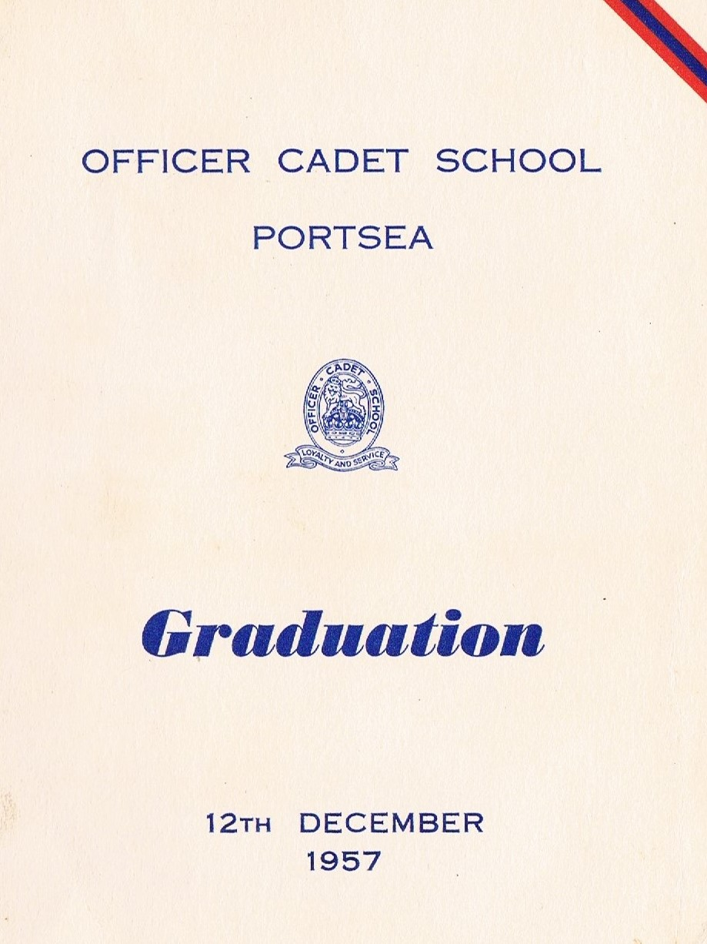

Graduation Program Cover.

OCS DEC ’57 GRADUATION CONT:
PROGRAM

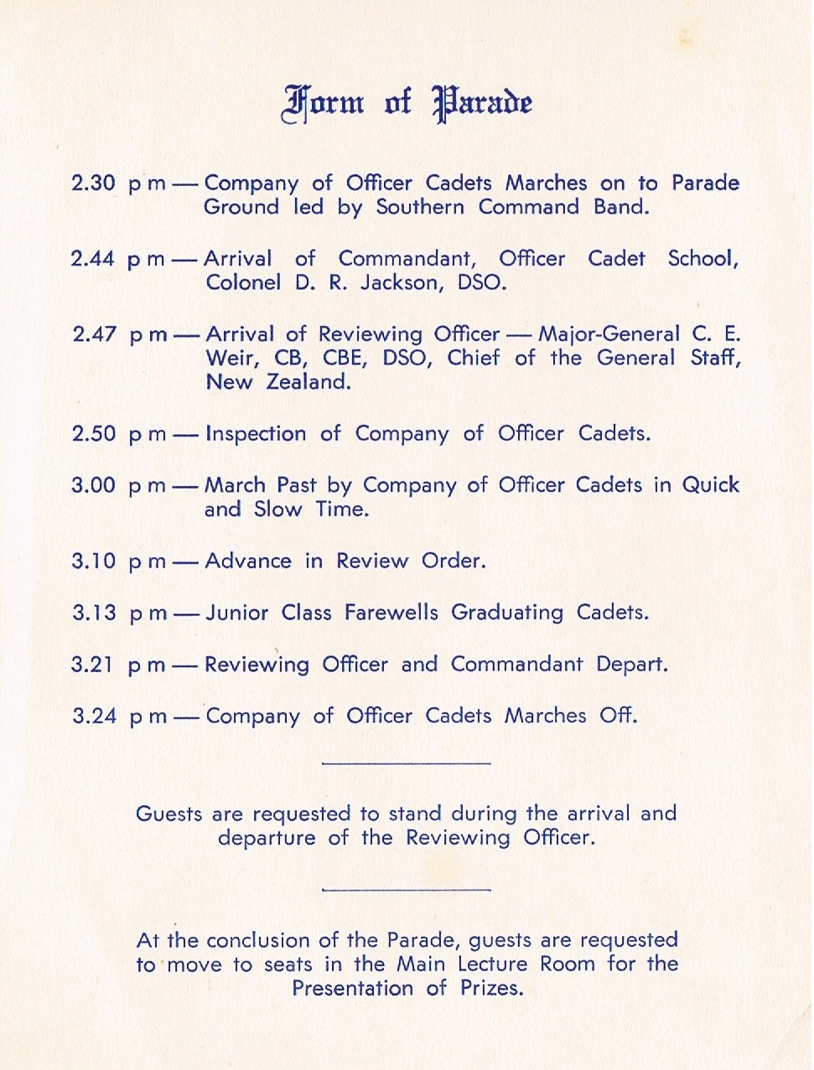

And it went like clockwork. It was quite fitting for the NZ CGS to be the Reviewing Officer.
GRADUATION PARADE – 12TH DECEMBER 1957

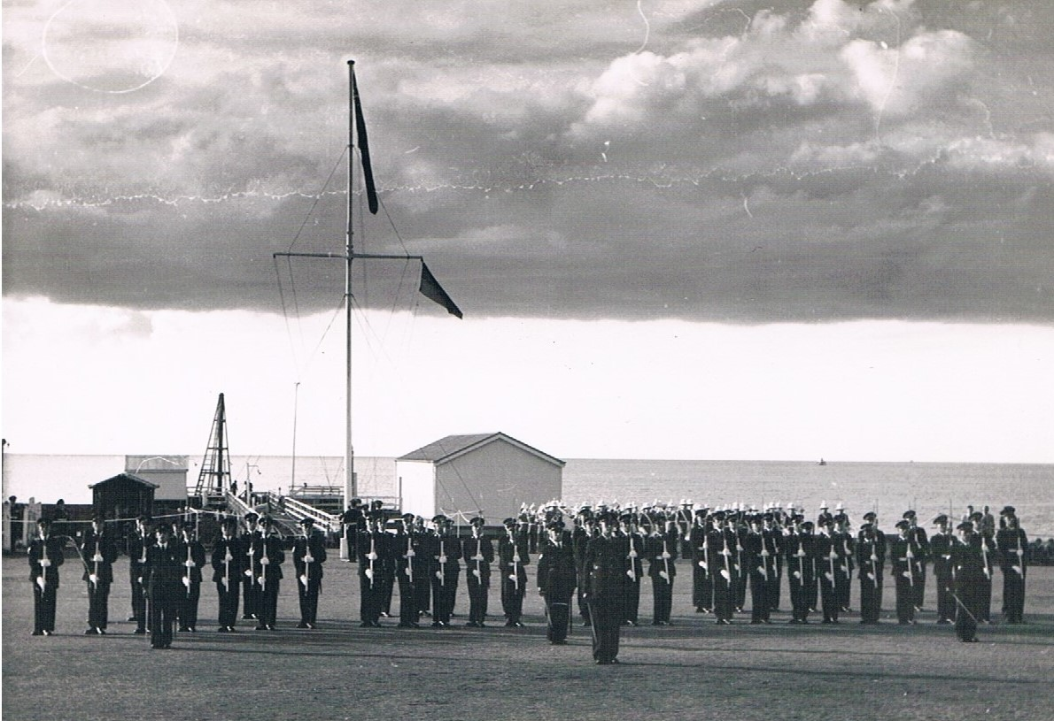

THE INSPECTION

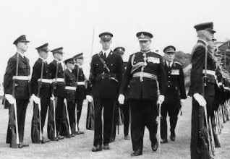

NZ Chief of the General Staff Major General C.E. Weir, CB, CBE, DSO reviews the graduating class accompanied by CSM, Company of Officer Cadets, Tony Ancell. Rear of Reviewing Officer: OCS Commandant Colonel D.R. Jackson, DSO.
OCS DEC ’57 GRADUATION CONT:
THE MARCH PAST

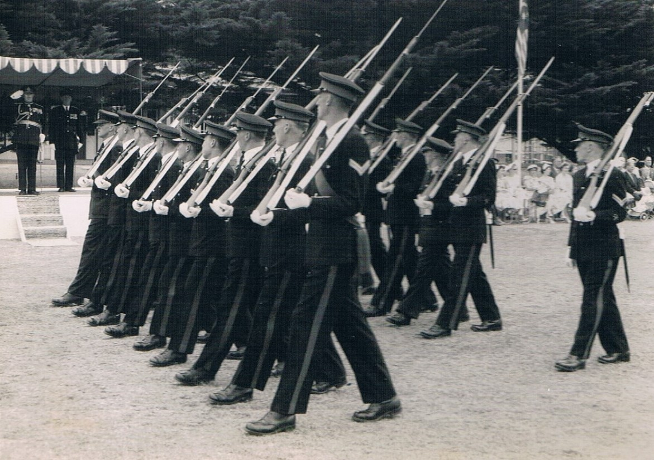

March Past in Slow Time.

THE COMPULSORY PHOTO SHOOT

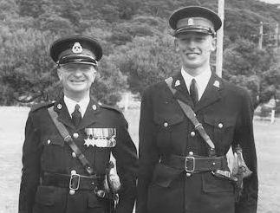

Compulsory Grad Day Photo Shoot with OCS RSM: WO 1 Roy Hockings & Cadet CSM Tony Ancell.
[Note: Tony was required to “lower” himself due to a major height disparity].
OCS GRADUATION PRESENTATIONS – DEC 1957

GOVERNOR GENERAL’S MEDAL
FOR CADET GRADUATING FIRST IN CLASS

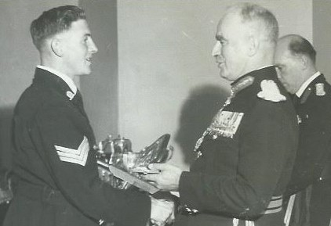
Award Winner Dec ’57 – Cadet Sgt Tom Heesom.
MILITARY BOARD PRIZE FOR EXEMPLARY CONDUCT & OUTSTANDING PERFORMANCE OF DUTY
[Later Replaced by Sword of Honour in Dec 1965].

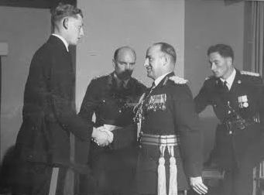

Presentation of MBI Prize to NZ Cadet CSM Tony Ancell by the NZ CGS, Maj Gen C.E. Weir, CB, CBE, DSO.
L to R: CSM Tony Ancell, OCS Commandant Col D.R. Jackson, DSO, Maj Gen Weir, NZ CGS & Capt Derek Deighton [later in career Maj Gen].
OCS DEC ’57 GRADUATION CONT:

FIELD/TACTICS PRIZE

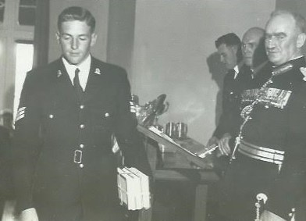

Cadet Sgt Tom Heesom conducting a “Planned Withdrawal”.
STAFF PRIZE

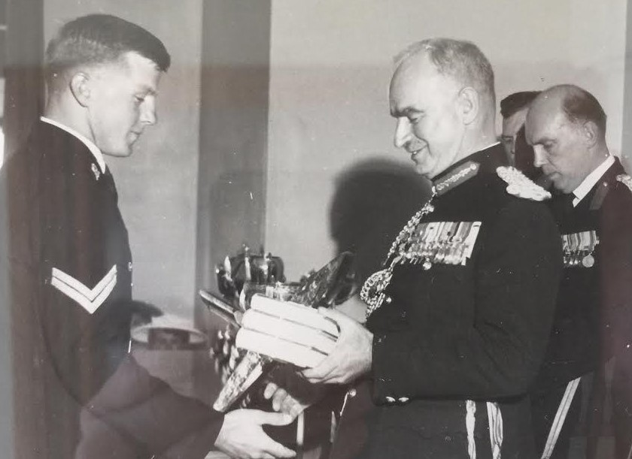

Cadet Cpl Michael Gill receives his award.
OCS DEC ’57 GRADUATION CONT:
NOT JUST A PIECE OF PAPER!

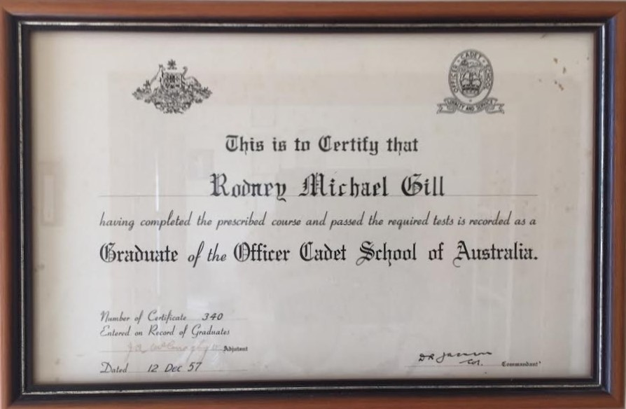

OCS Graduate Number 340 – Rodney Michael Gill.

RAAF GRADUATE

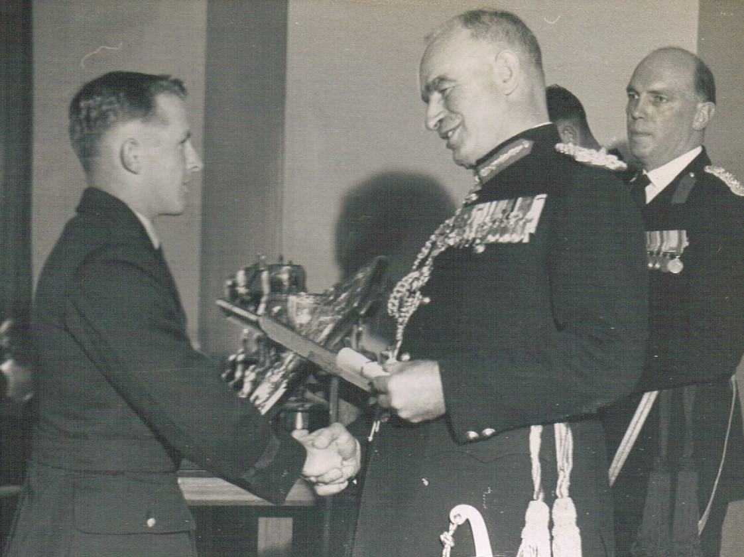

Barry Williamson receives his Certificate of Graduation.
OCS DEC ’57 GRADUATION CONT:

“IT IS WRITTEN THEREFORE IT MUST BE TRUE!”
- NO “FAKE” NEWS HERE –

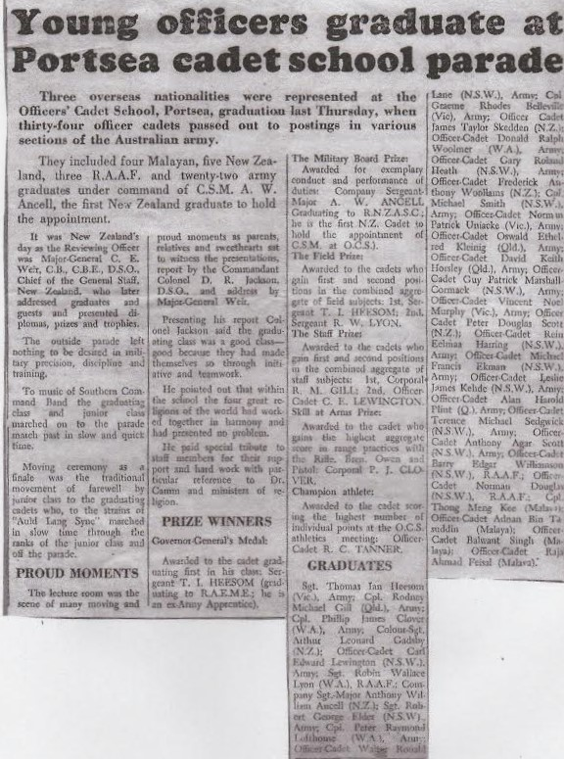

The Record of the Event: Herald Sun - 13th Dec '57. Ex Apprentices {Tom Heesom, Michael Gill & Phil Clover} placed 1, 2 & 3 in Class respectively. Our other Ex-Appy, Reg Elder, was placed 8th in Class on Graduation. The graduation was also well-covered in print & on ABC Radio mainly due to the first groups of overseas’ cadets from Malaya & NZ.
OCS DEC ’57 GRADUATION CONT:

A GUIDE FOR THE FUTURE

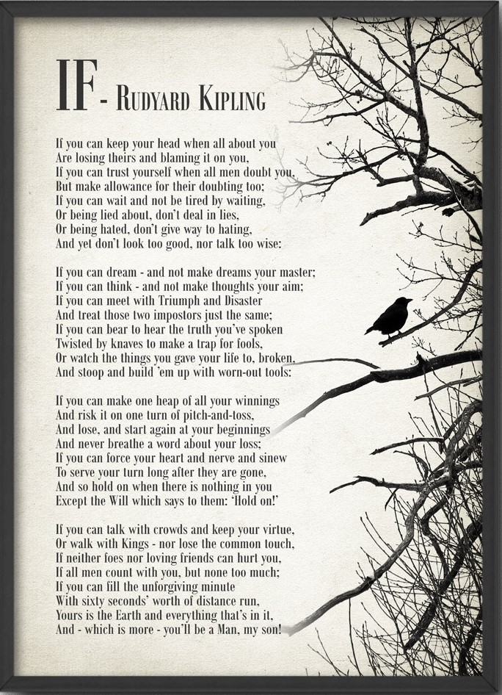

Padre's Parting Words of Wisdom to each Dec '57 Graduate.
OCS DEC ’57 GRADUATION CONT:

THE QUEEN’S COMMISSION

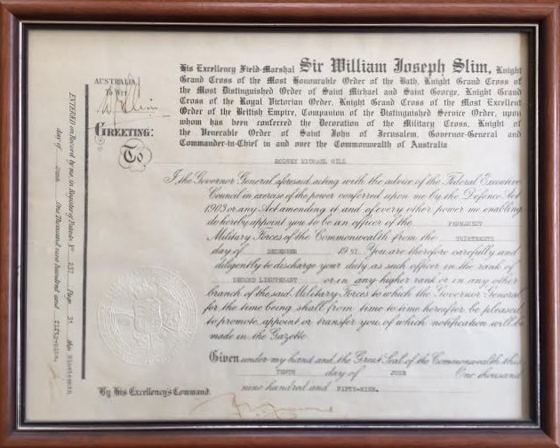
The Queen's Commission - Rodney Michael Gill.
OUR RAAF GRADUATES
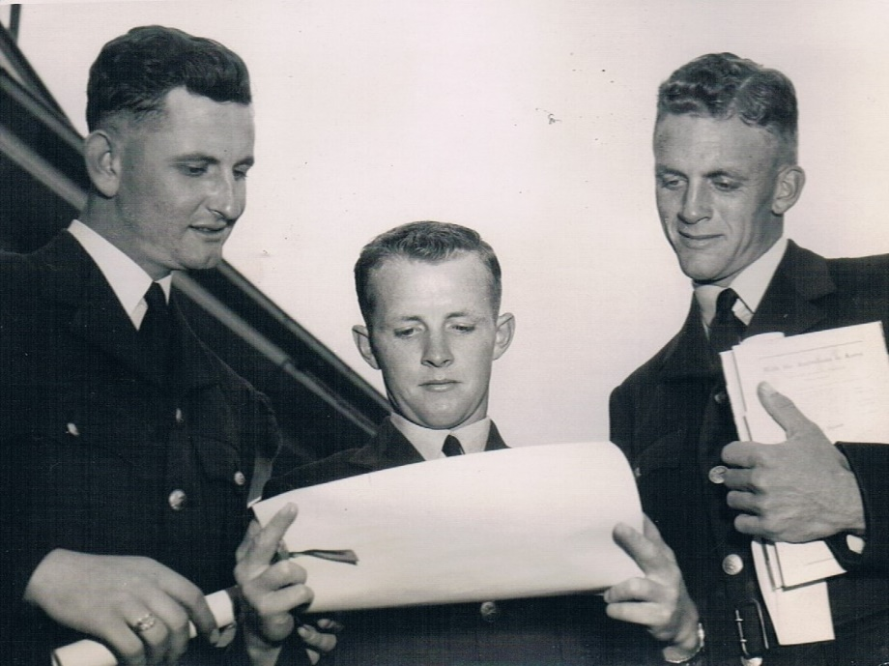
L to R: Norm Douglas, Barry Williamson & Rob Lyon.
OCS DEC ’57 GRADUATION CONT:
OUR MALAYAN GRADUATES
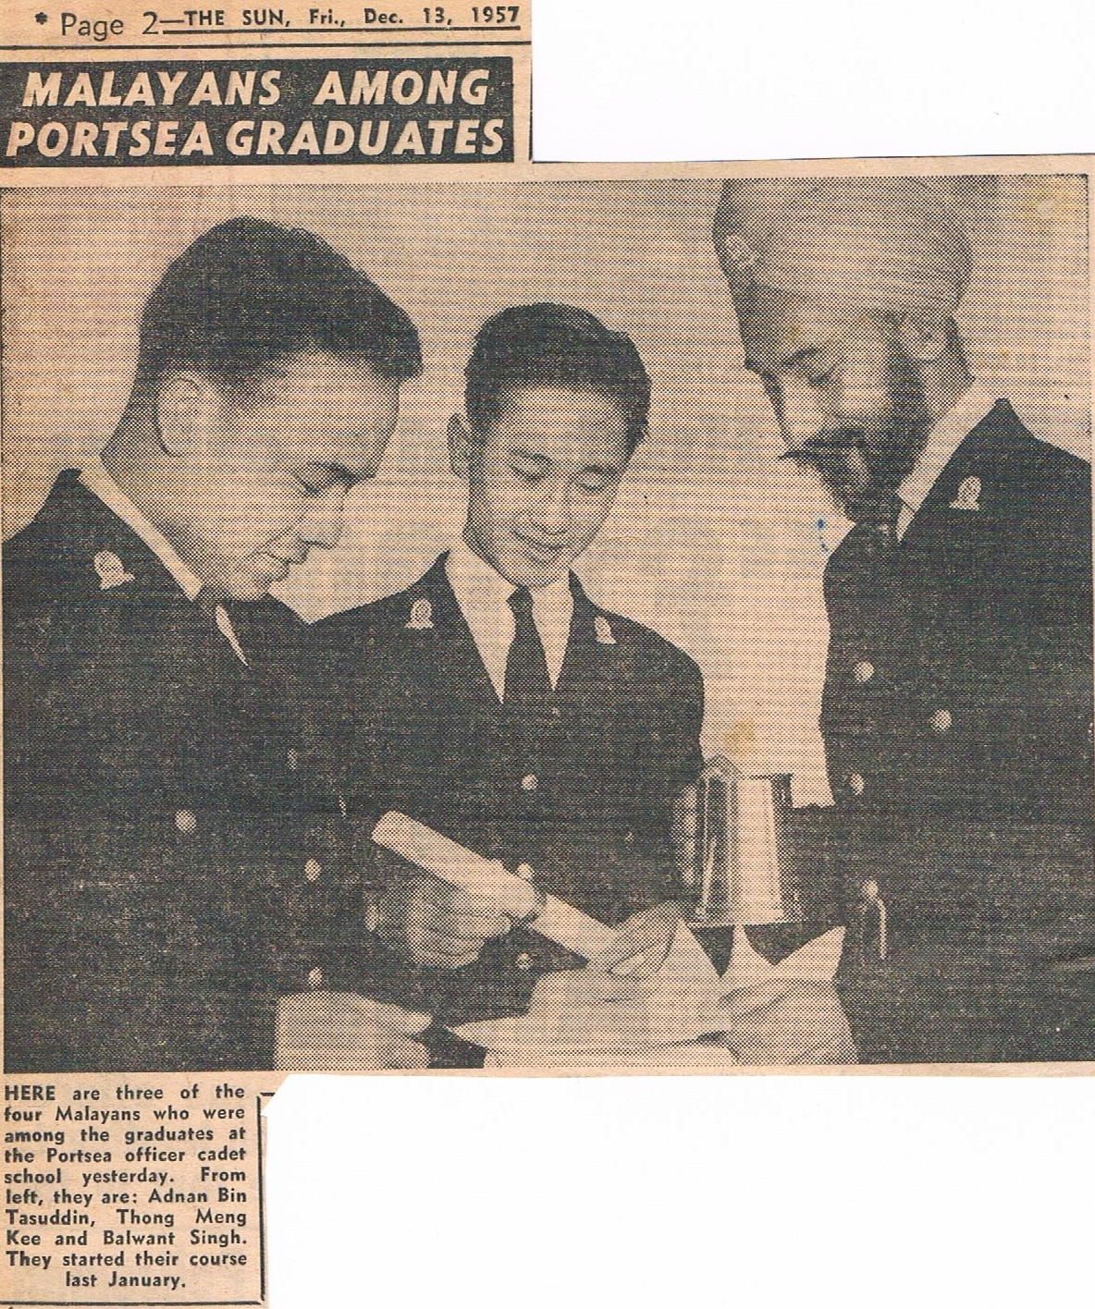
Only Raja Ahmad Feisal Missing from this Photo Shoot.
OCS DEC ’57 GRADUATION CONT:
THE “JUG”
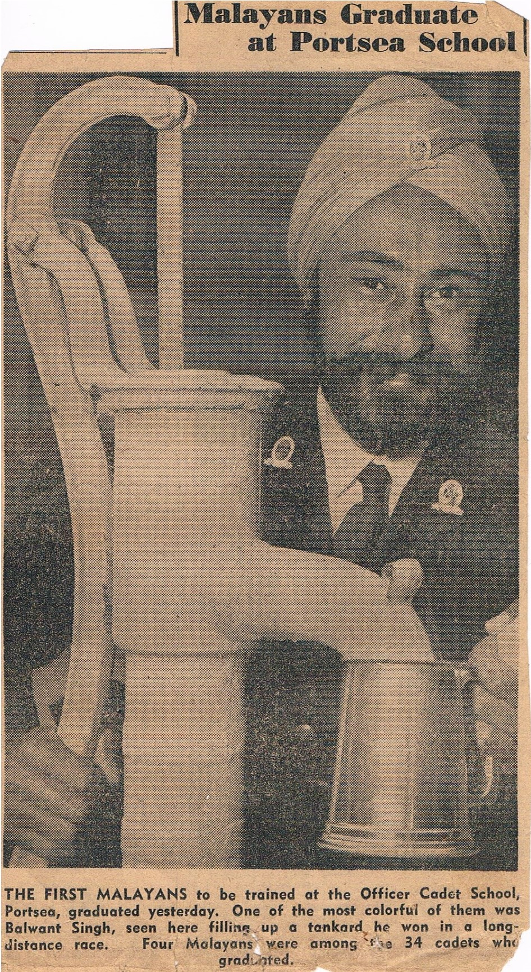
Balwant fills his jug.
OCS DEC ’57 GRADUATION CONT:
GRADUATION BALL
[It Takes a Kiwi to find a Kiwi].

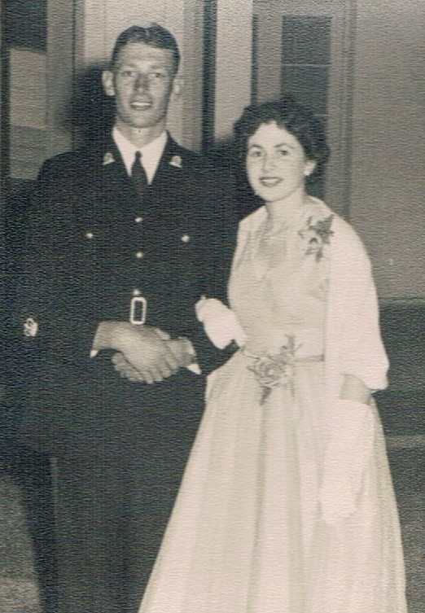
Still a Cadet. Tony Ancell & Partner Beulah, a visitor from Auckland.
“THE BEWITCHING HOUR” COMETH!
[Midnight plus One Second].

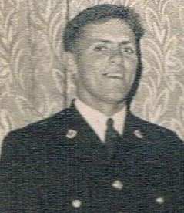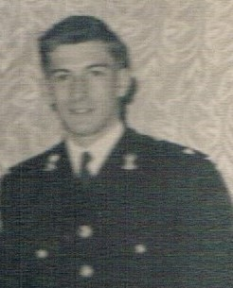

About to Be Launched Onto An Unsuspecting Army.
2 Lts Gary Heath, RAASC & Pat Marshall-Cormack, RAA.
It’s Done!

POST OCS DAYS
LIFE AS A “ONE-PIPPER”
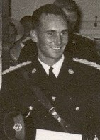
2 Lt Ossie Kleinig, RA Inf.
IS THERE NO ESCAPE?
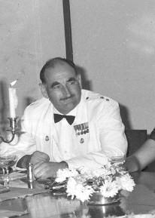
OCS DAYS: Maj A.B. Stretton, MBE - AKA "Justice” Stretton.
Favourite Saying: “28 Days – March Out!” Photo: CO Appointment 2 RAR Malaysia.

POST OCS DAYS CONT:
POST GRAD SERVICE – MALAYSIA 1961 to 63
2 RAR COLOUR PARTY

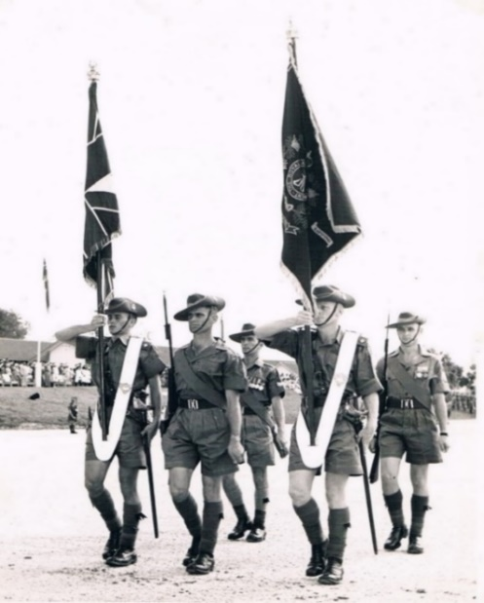
"Two Poor Drill Men" morphed into "Two Perfect Drill Men"!!!
L: Lt Ossie Kleinig – Queen’s Colour; R: Lt Vin Murphy – Regimental Colour.
Camp Terendak, Malaysia 1962.
COMBINED CLASSES OF DEC ’57 & JUN ’58 REUNION PHOTOS
LUNCHEON CRUISE - BRISBANE RIVER – NOV 2008

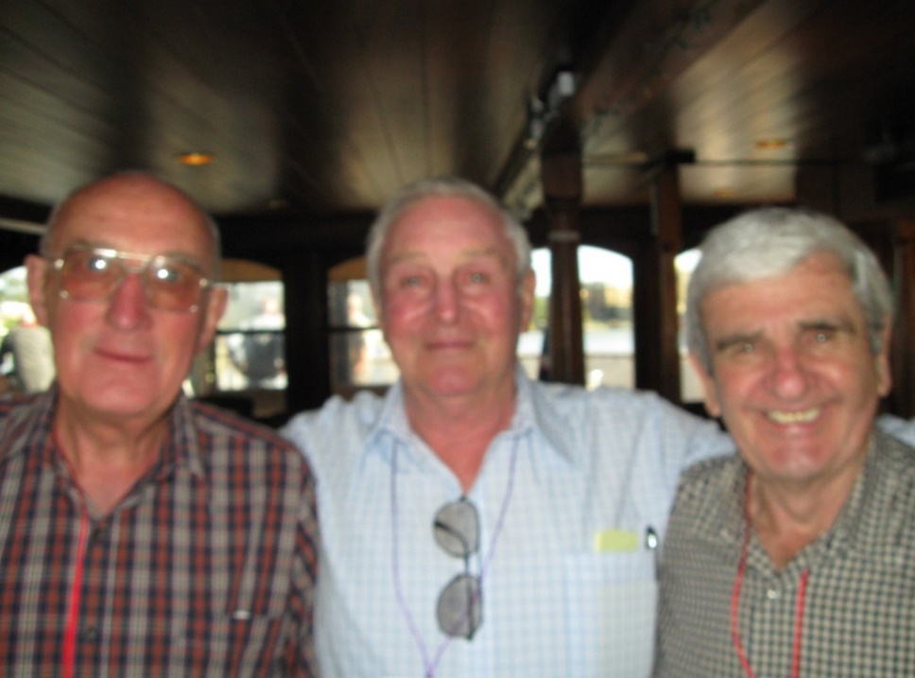

L to R: Reg Elder, Tom Heesom & Max Lockwood [Max – Jun ‘58 Graduate].
Three of our finest from the Army Apprentices School, Balcombe.
2008 REUNION PHOTOS CONT:
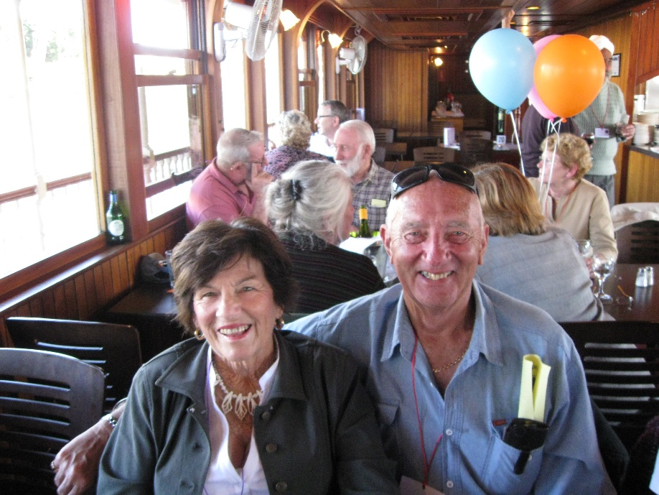
Norma & Bob McGhie. Bob also decided to seek “greener pastures” & return to Civvy Street.

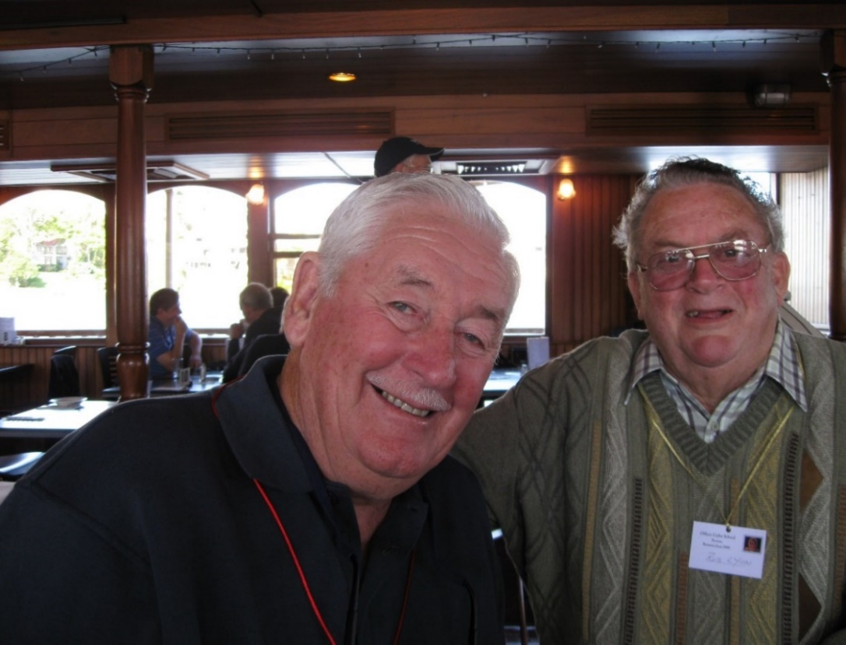

L to R: Michael Smith & Rob Lyon.
2008 REUNION PHOTOS CONT:
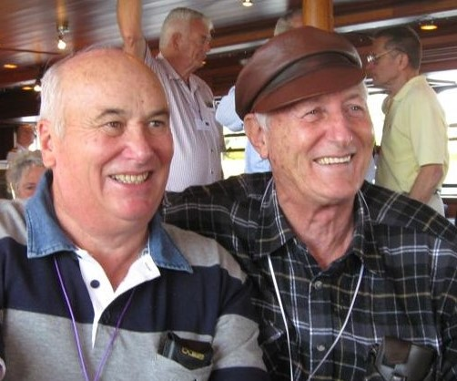
L to R: Ossie Kleinig & Geoff Chipman [Geoff - Jun '58 Graduate & fellow OCS Staff Member mid- 1960s].
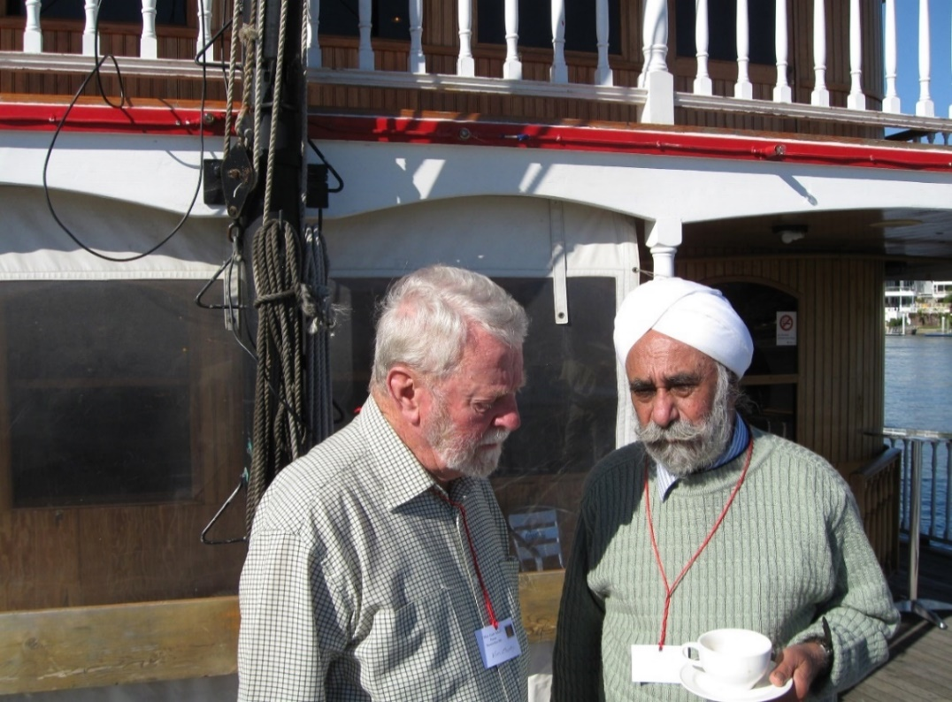
L to R: Vin Murphy & Balwant Singh.
2008 REUNION PHOTOS CONT:

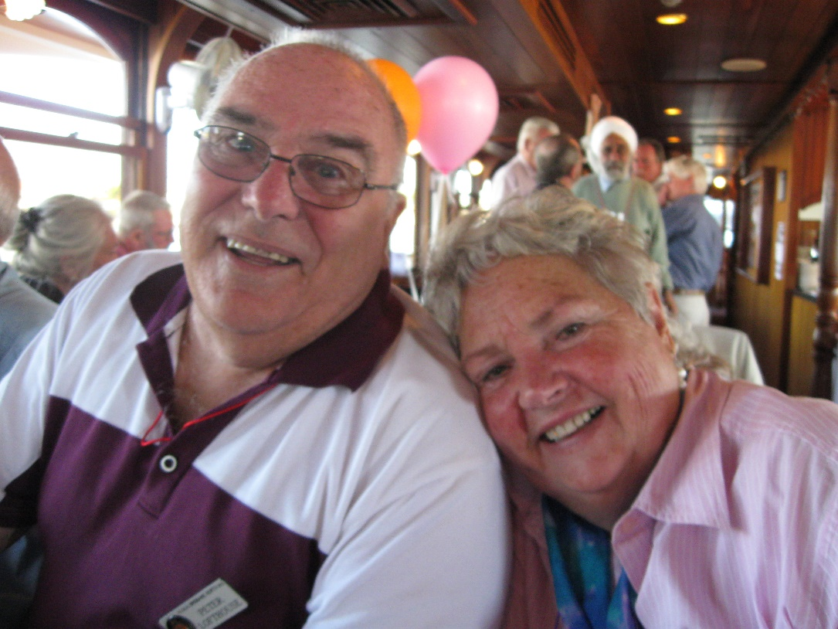
Peter & Denise Lofthouse.

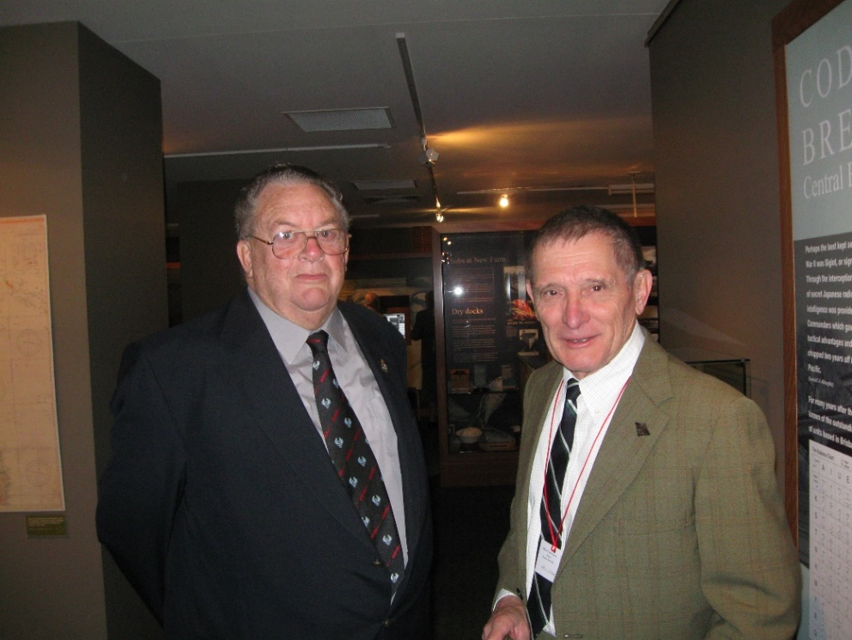

L to R: Rob Lyon & Phil Clover.
OCS CLASSES OF DEC ’57 & JUN ’58 - SERVICE
FOR DEPARTED CLASSMATES – SHRINE OF REMEMBRANCE BRISBANE

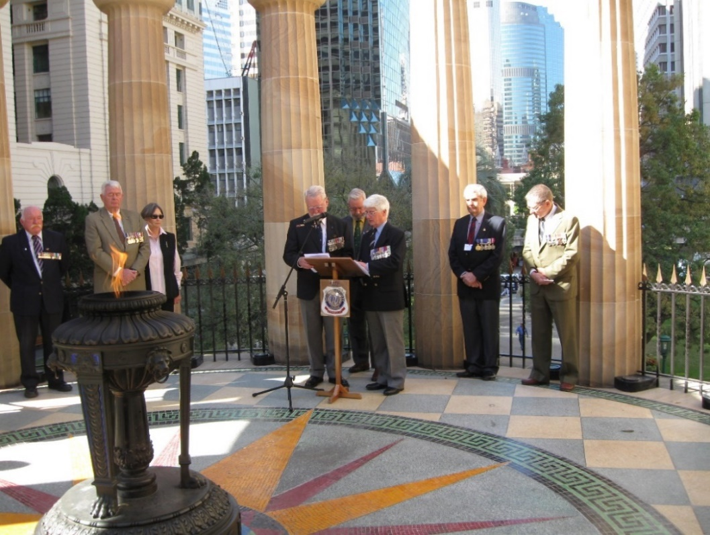

L to R: Derek Gough, Peter & Jan Howarth, Vin Murphy*, Rear - John Clarke, Brian Cudby, Max Lockwood & Phil Clover*.
[* Class of Dec ’57 Members].

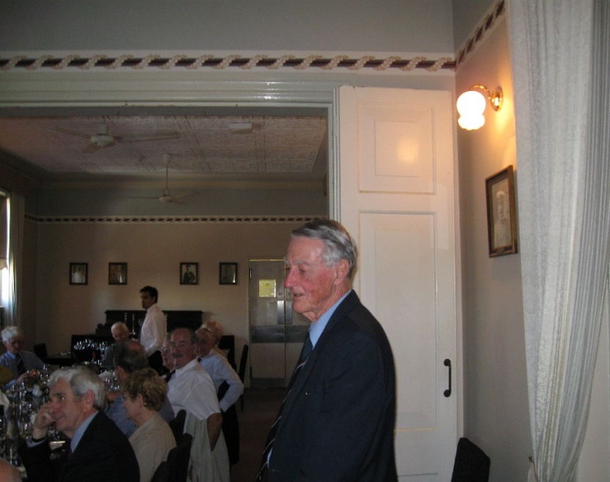

Luncheon Address by Colonel Neville Lyndsay on his OCS History “Loyalty & Service” at HQ Northern Command Mess.
2008 OCS REUNION CONT:

2008 REUNION DINNER – UNITED SERVICES CLUB - BRISBANE

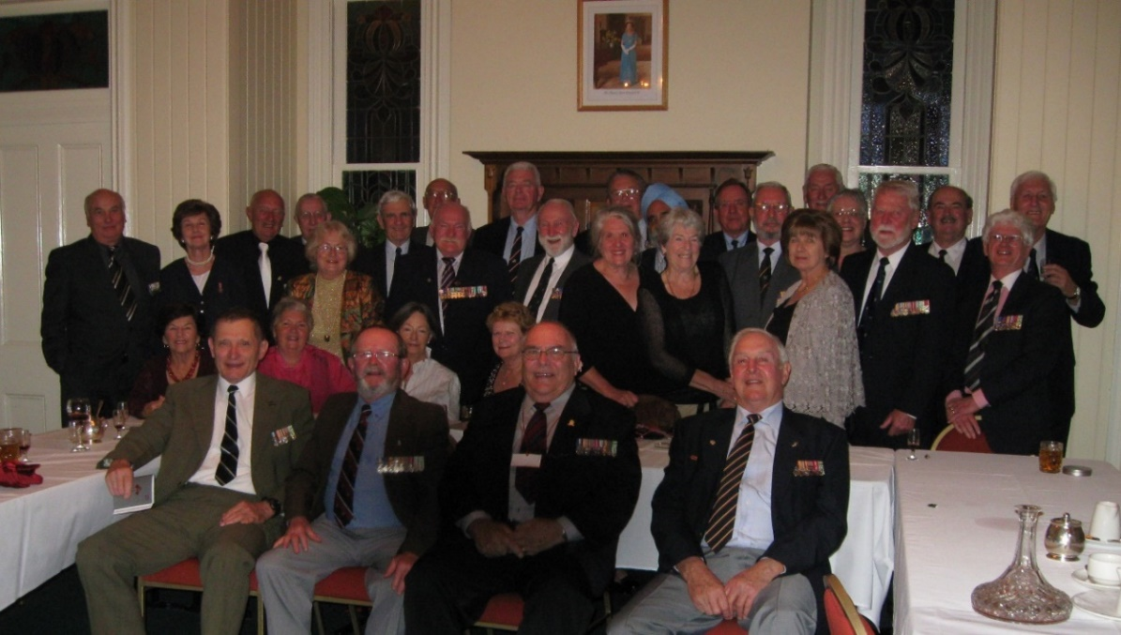

50 PLUS YEARS ON!
Back Row Standing L to R: Ossie Kleinig, Clare Heesom, Bob McGhie, Barry & Jillian Hawkins, Max Lockwood, Reg Elder behind Derek Gough, Peter Howarth, Terry & Jan Holland, Rear Rob Lyon & Balwant Singh, Marguerite Smith, Max Ball, John & Margaret Clarke, Rear Mick Smith, Robin Rodda, Vin Murphy, Quin Rodda, Brian Cudby & Geoff Chipman.
Ladies Seated Centre Row L to R: Norma McGhie, Denise Lofthouse, Jan Howarth & Janice Lockwood.
Front Row Seated L to R: Phil Clover, Barry Williamson, Peter Lofthouse & Tom Heesom.

REUNION DINNER VENUE

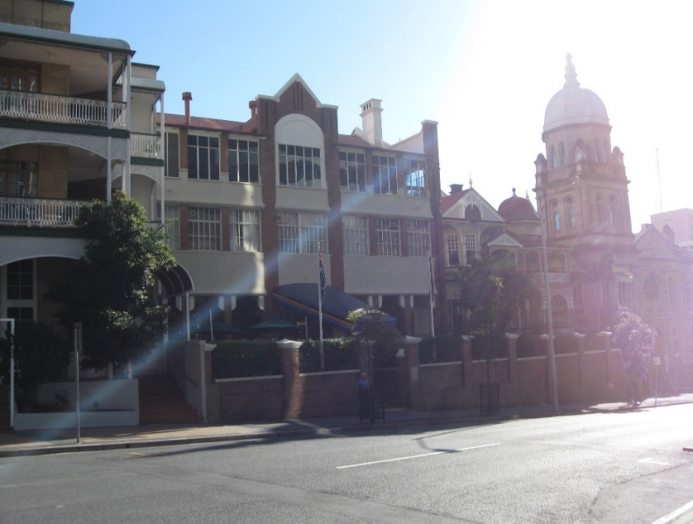

UNITED SERVICES CLUB – BRISBANE.
OCS COLOURS PRESENTATION

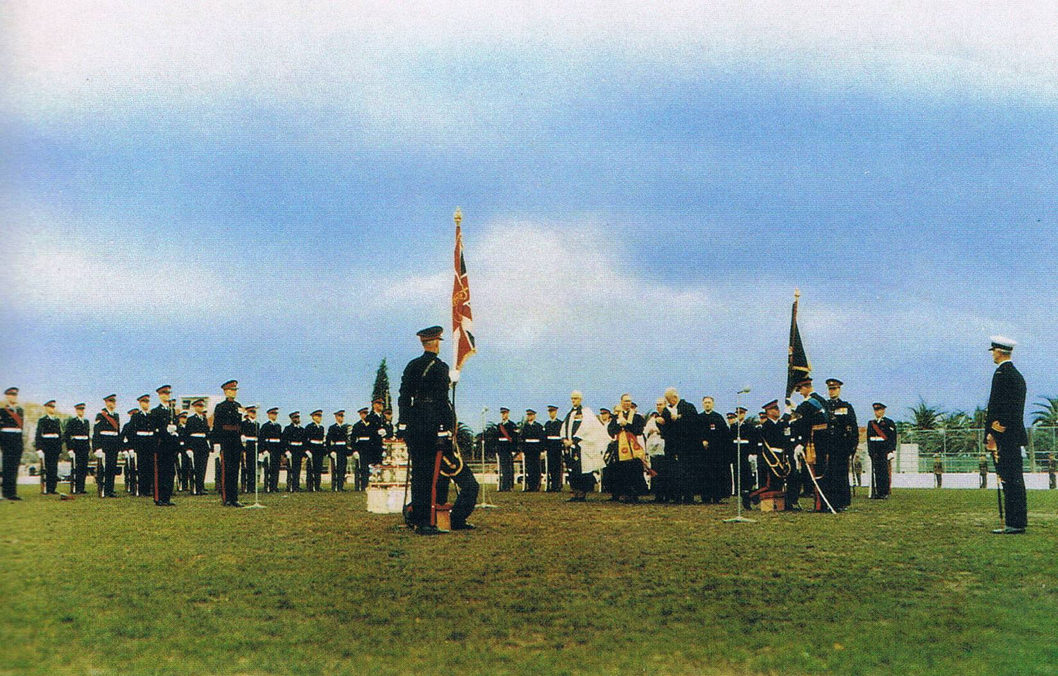

South Melbourne Cricket Ground.

COLOURS
LAID UP IN RMC DUNTROON ANZAC CHAPEL
23RD MARCH 1985
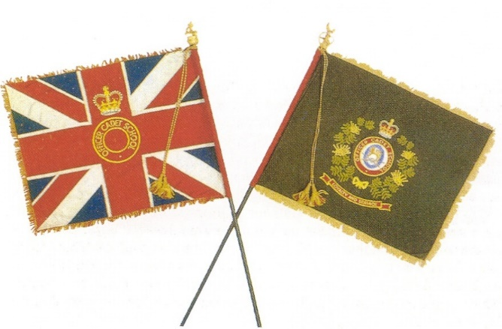
Presented by HRH Prince Phillip Duke of Edinburgh – 1st June 1968.
Well after our time!

