“Bring Them Home”

SARA’S STORY - THE DEATH OF LIEUTENANT DAVID JOHN BRIAN 3RAR ON MALAY-THAI BORDER OPERATIONS 5 MARCH 1964

Sara Ferguson was born in England during the Second World War, the eldest of three children. Her father was an infantry soldier who survived the war and later the conflict on the Korean Peninsula. In 1956 the family immigrated to Australia and settled in Sydney.

Sara met her future husband in Sydney and they married in the spring of 1962. In mid-1963 the Third Battalion Royal Australian Regiment deployed to Malaysia as part of 28 Commonwealth Brigade based in Terendak Garrison, just north of Malacca on the west coast of Malaysia. Sara joined her husband shortly after the arrival of the battalion in Malaysia. She fell pregnant with her first child later that year. She was 20years old.

Special operations were still being conducted on the border between Malaya and Thailand and the Third Battalion was sent on operations in February 1964. It was to be the last time an Australian battalion conducted operations in that area of the Malay Peninsula. Sara’s husband was killed while patrolling deep in the jungle.

This is Sara’s story.

“Heavily pregnant I was living by myself in a married quarter on the outskirts of Malacca some 30 km from Terendak Garrison, Malacca, Malaysia. The battalion was on operations where there was no personal contact with families back in the Garrison or where we lived other than by letter.

On the afternoon of 5 March 1964 I was advised of my husband’s death by a padre. He came to the house by himself and advised me of David’s death. He then immediately sought my permission to have David buried on the Malaysia-Thai border where he had been killed. I flatly refused and although devastated demanded that his remains be returned with me to Australia. I advised him that I would charter a plane if necessary. He left and I was left alone. I was seven months pregnant and went into labour. I sought help from a neighbour and the British doctor looking after my confinement was called. The British doctor refused to attend and subsequently a young Australian doctor came to the house. Following an injection of ‘calming’ drugs he took me to his home for the night.

The following day the Padre returned seeking my agreement again for David to be buried on the Malay-Thai border. Again I refused. I was later advised that my request for his remains to be sent back to Australia had also been refused on the grounds that there were no facilities. At my insistence it was finally agreed that he would be buried in the newly established garrison but empty cemetery in the confines of the military garrison, the newly built Terendak Camp, Malacca. It was a relatively large open grassed area and that was all. It was of great concern and distress to me that his was to be the only grave in the cemetery. My concern was well founded, as the headstone for his grave was not erected for another nine months.

The Commanding Officer of the unit came to visit me on his return to the base for the funeral. He offered condolences but no explanation as to how David was actually killed or as to why I could not have his remains returned to Australia even at my expense.

Because of my advanced pregnancy I could not attend my husband’s funeral. In addition, my request to see my husband’s body was refused [because of bullet injuries to his head]. In hindsight both decisions were extremely bad as there was no ‘closure’ on his death. This was something I have had to live with. I was never told of my rights. The whole objective seemed to be to get me out of the area and back to Australia as soon as possible.

The Media release in Australia mentioned only David. I felt I did not exist although I was carrying his child (copy under).

I was taken to Singapore and despite my condition put on a plane to Australia without escort. I was met at Sydney airport by military staff that guided me through customs then left. My parents and parents-in-law were waiting. My parents-in-law took me to their residence. I was shattered but I was within a few weeks the child of my beloved husband being born and with that came responsibility.

On return to Australia all the bank accounts had been frozen for probate and death duties. There was no initial help from the Army or as I now know the then Department of Veterans Affairs. I had to borrow. It was autumn, I was heavily pregnant and having come from the heat of Malaysia I needed clothes. As well as dealing with the death of my husband I had to prepare for the arrival of our child. As I was unable to access funds my parents-in-law bought me the essential clothes and provided the accommodation I needed. They later rented me a flat they owned adjacent to where they lived. At no stage was I given any advice or help by the Army or any arm of Government. There was no lump sum, no compensation, no advance of monies due or any advice whatsoever. But what I did receive was a Mess Bill for my husband’s Mess Account from his Battalion’s in Malaysia.

In addition, the DFRDB and War Widows pensions did not commence for some considerable period after I returned to Australia. Without the help of relatives I would have been left with nothing to live on.

In my ninth month of pregnancy I had a severe haemorrhage in the early hours of 21 May 1964 and I was rushed to hospital. My parents were advised that they should be prepared for the strong possibility that neither my child nor I would survive. We did, albeit in the emergency operation I was cut vertically through the stomach muscles that left very significant scaring and internal damage. This severely impacted on my physical looks, health, and ability to lead an active outdoor life and importantly to have children subsequently. Since that time I have had six major operations that ultimately culminated in a hysterectomy in my early thirties and the onset of menopause at age 37.

Following the birth of my son I decided that I should buy a house and applied for a War Service Home Loan. This was denied on the basis that I did not have enough income to repay the loan. The loan could never be accessed.

I submitted the hospital and related medical accounts to the Department of Veterans Affairs (DVA) for my emergency operation and birth of my son for refund. I was advised that they would not be paid, as confinements were not covered by DVA. I had to meet the very significant expenses. There was no compassion, discussion or consideration for my unique circumstances. Some considerable time later a military colleague of my late husband learned of my plight and through his action some of the costs were refunded.

I was a widow; I was at 21 years old with a son and accepted what the authorities said at that time.

While I received messages of condolence in Malaysia from the Army immediately following David’s death, on return to Australia there was no contact from the authorities whatsoever. No-one in the Services sought to see that I was comfortable or whether I needed help. Frankly, no-one seemed to care and certainly it appeared no-one wanted to bother with me.

I remained deeply distressed and disturbed that I had not been to my husband’s funeral and that I had not been able to see him before he was buried. Amongst other things, every time the doorbell rang I thought it might be him. My very caring doctor’s strong advice was that I should take positive action to attempt to ‘close out’ his death. I returned to Malacca some 18 months later to make my peace with David. This was at my own expense. I sat on his grave in Terendak Garrison and it helped but was no substitute for what I should have done at the time of his death. I desperately wanted to bring him home then and again and again. The trauma remained.

Our son, David, has grown into a fine Australian and followed his father into the Royal Military College and thus the officer corps of our Army. He saw Active Service and served over twenty years. He married and has three wonderful children. His grandmother (Mrs Phyllis Brian) was so looking forward to the return of the remains of her eldest son. Mrs Brian passed away on 3 May 2016 aged 102 yrs, a month before the return of her eldest son to Australian shores.

The Visit 2014

My husband and I visited the cemetery in April 2014. I was devastated at the state and we were also disturbed at inaccessibility of the site in Terendak Garrison, Malacca, Malaysia.

Having visited the grave site again, the hardest thing I have had to do in my life was to walk away. In simple terms I was shattered.

My husband and I decided then to do what no one else had achieved. To bring home all the Australians buried in the garrison cemetery including family members. That we have done but it has not been easy. Nor has the aftermath.

“Bring Them Home”

Our quest began immediately in April 2014 with representation to the Department of Veterans Affairs from overseas the day after the visit to the Cemetery. On return to Australia in May 2014 a preliminary written proposal was sent to the Department using the catch-phrase “ Bring them Home” followed by a personal visit to Canberra. We were advised that such a proposal would require a significant change of Government policy. Body language told us we had little hope.

My husband dedicated himself to achieve the unachievable. This was a ‘soldier’ issue. In cooperation with the Department of Veterans Affairs and Vietnam Veterans Federation of Australia we jointly fully researched the history and uncovered related appalling facts. It had never been done before. A revised draft submission keeping the catch-phrase “Bring Them Home” was prepared by August 2014 and was sent to Veterans organisations for comment. The telephone ran hot!

The comprehensive yet unique proposal sought to bring all the Australians interred in Terendak Garrison Cemetery back to Australia to be interred where their next of kin chose. Families had joined their soldier fathers and husbands and as happens many did not survive. We felt very strongly that deceased family members including deceased wives and children should be included.

The was a strong caveat that the repatriation to Australia of each individual was to be subject to next of kin (family) agreement.

Importantly, the proposal included not only the basic request to bring the soldiers home but how to do it and a plan with timings. It also proposed that New Zealand join Australia in the endeavour but this turned out to be impracticable. It is now being examined in detail by New Zealand on a positive basis.

The submission to Government also proposed that a ‘National War Cemetery’ should be established concurrently. This had previously been proposed by the then Prime Minister before his election. The initiative to establish the Villers-Bretenau Memorial has taken priority for the present.

The submission to Government

In late October 2014 a final submission was ready that not only addressed the issues but provided a solution and plan. Common-sense demanded that it be held then submitted after the international APEC meeting in Sydney in November 2014. It was sent to the appropriated Australian Government ministers and concurrently to all political parties and some fifty prominent Australians. The response was overwhelmingly positive.

In December 2014 my husband received a call from Senator the Hon Michael Ronaldson, the then Minister for Veterans Affairs, and they met in Brisbane. It was a highly professional yet emotional meeting and the Minister agreed the facts in the submission were correct and with the thrust of the proposal. He indicated he needed to be sure that all would agree and sought to meet again with my husband together the Presidents of the two Vietnam Veterans organisation. At short notice this meeting occurred in Sydney in late December 2014.

It is important to note that the Vietnam Veterans Federation of Australia had been heavily involved with the development of our submission but the Vietnam Veterans Association of Australia had not. However, at the meeting with the Minister of Veterans Affairs in Sydney the President endorsed the proposal without condition. The Minister agreed to progress the matter through normal government processes. He indicated that the then Prime Minister, Tony Abbott, was aware of the impending proposal and was in favour.

The Minister was very confident that he would succeed. He then asked the President of the Vietnam Veterans Association of Australia to have a Petition that had been independently launched out of Darwin from the Associations Darwin Chapter shut down. Regrettably, and well aware of our progress it took our well known catch phrase of “Bring Them Home” to head the Petition and concurrently launched a Crowd Funding request seeking $800.000 to return just the Vietnam causalities.

The request by the President to the VVAA (NT) was denied and following a separate plea by us it was for a short time.

Confident of success we proceeded overseas only to learn that the Petition was again released four weeks later albeit it was never presented to Parliament.

Announcement

In May 2015 my husband and I were invited to Canberra with others for the Australian Government announcement that the families of all Australians buried in Terendak Garrison Cemetery would be offered the opportunity to bring their loved ones home.

In the implementation of the decision by the Government has been principally under the guidance by the Department of Veterans Affairs, other Government Departments as well as the Australian Defence Force. It has been has been complex but has basically followed the outline plan we proposed.

The dedication and competence of all involved has been so impressive it is hard to believe. We are so very grateful and are now at peace. Others have reflected the same sentiment.

This endeavour was about all the Australians, the soldiers and family members including children buried in Terendak and was undertaken for the sake of the families. We had a courageous and very caring Minister, Senator (R) Michael Ronaldson, and the then Prime Minister, Tony Abbott, to thank for their unstinting support.

May 2016

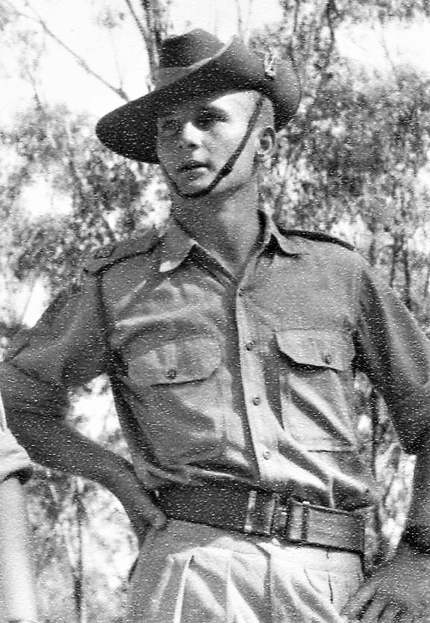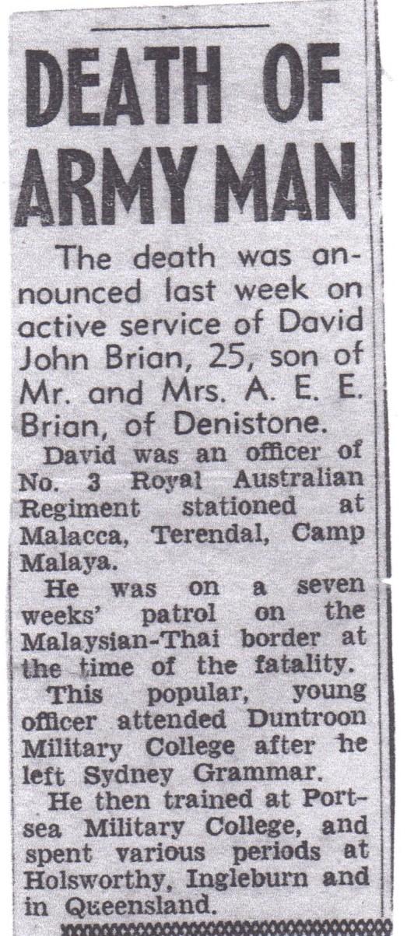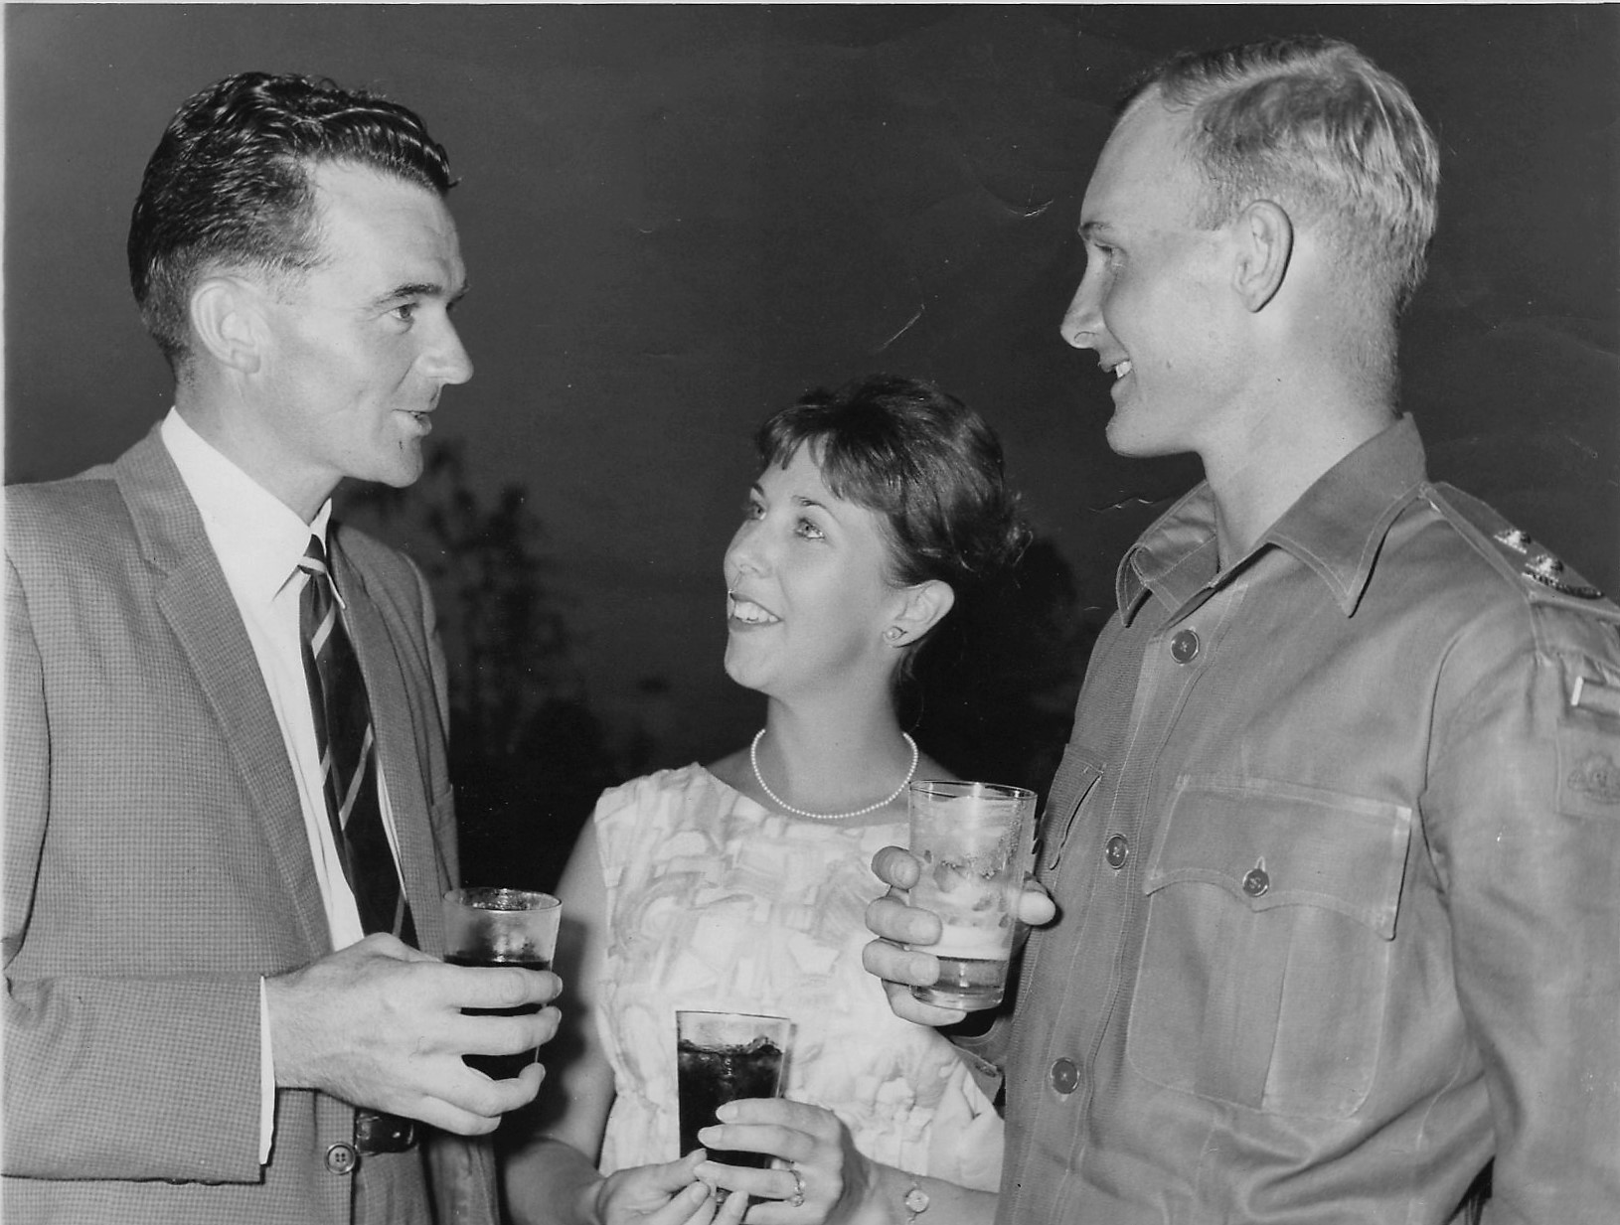

Lt David Brian 3 RAR Media-March 1964 David and Sara Brian in Malaysia 1964

